**Lab 5**

**Tên: Trần Đức**

**MSSV:1150080131**

**Thực hành 1: Tạo và kết nối CSDL ngay bên trong Project Winform.**

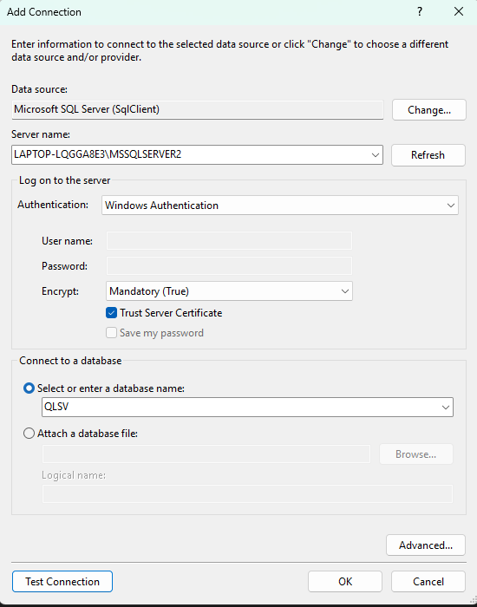

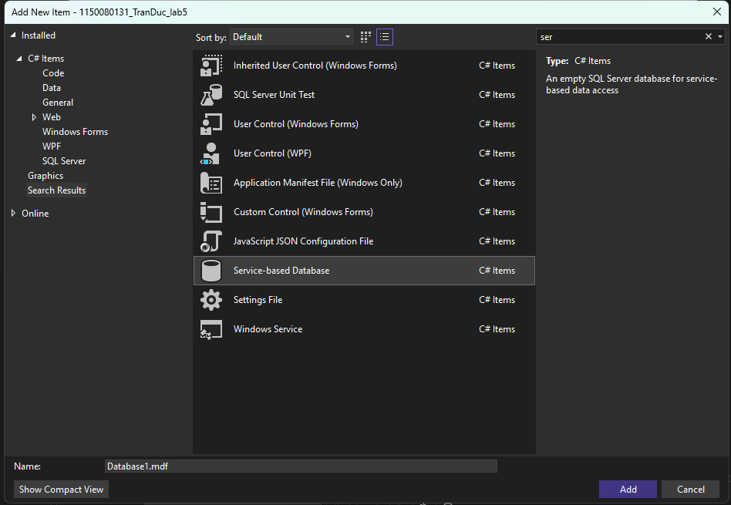

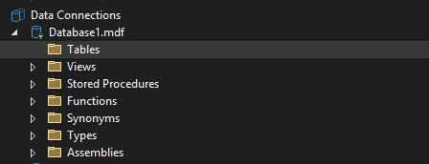

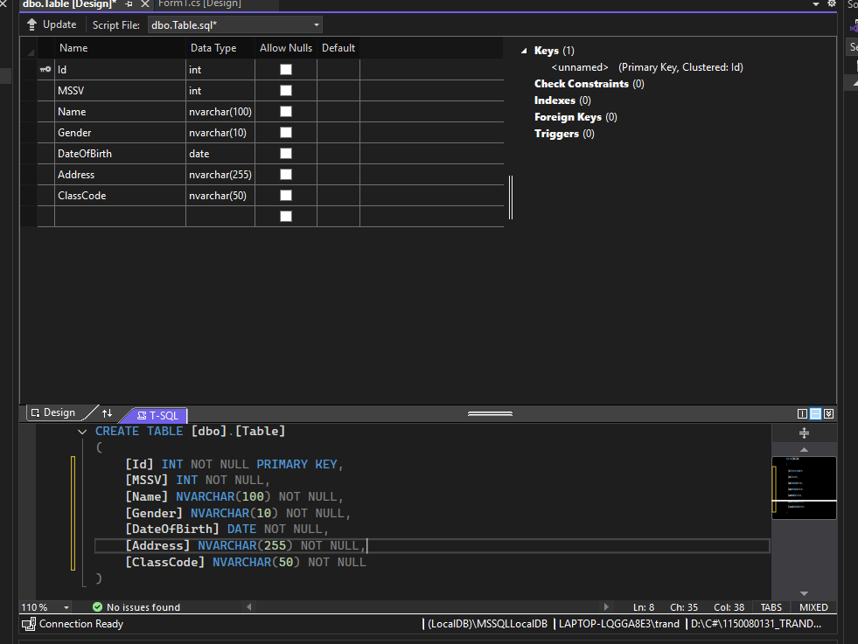

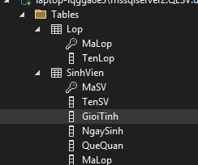

**Thực hành 2: Thêm dữ liệu không dùng Parameter.**

<connectionStrings>

<add name="QLSV"

connectionString="Data Source=LAPTOP-LQGGA8E3\MSSQLSERVER2;Initial Catalog=QLSV;Integrated Security=True;Persist Security Info=False;TrustServerCertificate=True" />

</connectionStrings>

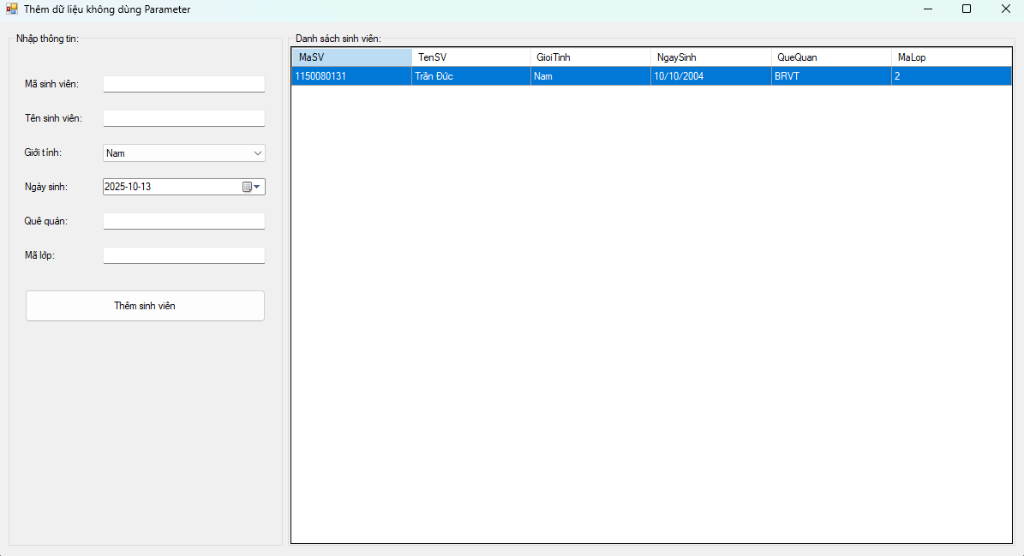

namespace _1150080131_TranDuc_lab5

{

partial class Form1

{

private System.ComponentModel.IContainer components = null;

private System.Windows.Forms.GroupBox grpNhap;

private System.Windows.Forms.Label label1;

private System.Windows.Forms.TextBox txtMaSV;

private System.Windows.Forms.Label label2;

private System.Windows.Forms.TextBox txtTenSV;

private System.Windows.Forms.Label label3;

private System.Windows.Forms.ComboBox cboGioiTinh;

private System.Windows.Forms.Label label4;

private System.Windows.Forms.DateTimePicker dtNgaySinh;

private System.Windows.Forms.Label label5;

private System.Windows.Forms.TextBox txtQueQuan;

private System.Windows.Forms.Label label6;

private System.Windows.Forms.TextBox txtMaLop;

private System.Windows.Forms.Button btnThem;

private System.Windows.Forms.GroupBox grpDS;

private System.Windows.Forms.DataGridView dgvSV;

protected override void Dispose(bool disposing)

{

if (disposing && (components != null)) components.Dispose();

base.Dispose(disposing);

}

private void InitializeComponent()

{

this.grpNhap = new System.Windows.Forms.GroupBox();

this.btnThem = new System.Windows.Forms.Button();

this.txtMaLop = new System.Windows.Forms.TextBox();

this.label6 = new System.Windows.Forms.Label();

this.txtQueQuan = new System.Windows.Forms.TextBox();

this.label5 = new System.Windows.Forms.Label();

this.dtNgaySinh = new System.Windows.Forms.DateTimePicker();

this.label4 = new System.Windows.Forms.Label();

this.cboGioiTinh = new System.Windows.Forms.ComboBox();

this.label3 = new System.Windows.Forms.Label();

this.txtTenSV = new System.Windows.Forms.TextBox();

this.label2 = new System.Windows.Forms.Label();

this.txtMaSV = new System.Windows.Forms.TextBox();

this.label1 = new System.Windows.Forms.Label();

this.grpDS = new System.Windows.Forms.GroupBox();

this.dgvSV = new System.Windows.Forms.DataGridView();

this.grpNhap.SuspendLayout();

this.grpDS.SuspendLayout();

((System.ComponentModel.ISupportInitialize)(this.dgvSV)).BeginInit();

this.SuspendLayout();

//

// grpNhap

//

this.grpNhap.Anchor = ((System.Windows.Forms.AnchorStyles)(((System.Windows.Forms.AnchorStyles.Top | System.Windows.Forms.AnchorStyles.Bottom)

| System.Windows.Forms.AnchorStyles.Left)));

this.grpNhap.Controls.Add(this.btnThem);

this.grpNhap.Controls.Add(this.txtMaLop);

this.grpNhap.Controls.Add(this.label6);

this.grpNhap.Controls.Add(this.txtQueQuan);

this.grpNhap.Controls.Add(this.label5);

this.grpNhap.Controls.Add(this.dtNgaySinh);

this.grpNhap.Controls.Add(this.label4);

this.grpNhap.Controls.Add(this.cboGioiTinh);

this.grpNhap.Controls.Add(this.label3);

this.grpNhap.Controls.Add(this.txtTenSV);

this.grpNhap.Controls.Add(this.label2);

this.grpNhap.Controls.Add(this.txtMaSV);

this.grpNhap.Controls.Add(this.label1);

this.grpNhap.Location = new System.Drawing.Point(12, 12);

this.grpNhap.Name = "grpNhap";

this.grpNhap.Size = new System.Drawing.Size(320, 600);

this.grpNhap.TabIndex = 0;

this.grpNhap.TabStop = false;

this.grpNhap.Text = "Nhập thông tin:";

//

// btnThem

//

this.btnThem.Location = new System.Drawing.Point(19, 300);

this.btnThem.Name = "btnThem";

this.btnThem.Size = new System.Drawing.Size(281, 38);

this.btnThem.TabIndex = 12;

this.btnThem.Text = "Thêm sinh viên";

this.btnThem.UseVisualStyleBackColor = true;

this.btnThem.Click += new System.EventHandler(this.btnThem_Click);

//

// txtMaLop

//

this.txtMaLop.Location = new System.Drawing.Point(110, 250);

this.txtMaLop.Name = "txtMaLop";

this.txtMaLop.Size = new System.Drawing.Size(190, 22);

this.txtMaLop.TabIndex = 6;

//

// label6

//

this.label6.AutoSize = true;

this.label6.Location = new System.Drawing.Point(16, 253);

this.label6.Name = "label6";

this.label6.Size = new System.Drawing.Size(50, 16);

this.label6.Text = "Mã lớp:";

//

// txtQueQuan

//

this.txtQueQuan.Location = new System.Drawing.Point(110, 210);

this.txtQueQuan.Name = "txtQueQuan";

this.txtQueQuan.Size = new System.Drawing.Size(190, 22);

this.txtQueQuan.TabIndex = 5;

//

// label5

//

this.label5.AutoSize = true;

this.label5.Location = new System.Drawing.Point(16, 213);

this.label5.Name = "label5";

this.label5.Size = new System.Drawing.Size(64, 16);

this.label5.Text = "Quê quán:";

//

// dtNgaySinh

//

this.dtNgaySinh.Location = new System.Drawing.Point(110, 170);

this.dtNgaySinh.Name = "dtNgaySinh";

this.dtNgaySinh.Size = new System.Drawing.Size(190, 22);

this.dtNgaySinh.TabIndex = 4;

//

// label4

//

this.label4.AutoSize = true;

this.label4.Location = new System.Drawing.Point(16, 173);

this.label4.Name = "label4";

this.label4.Size = new System.Drawing.Size(68, 16);

this.label4.Text = "Ngày sinh:";

//

// cboGioiTinh

//

this.cboGioiTinh.DropDownStyle = System.Windows.Forms.ComboBoxStyle.DropDownList;

this.cboGioiTinh.Location = new System.Drawing.Point(110, 130);

this.cboGioiTinh.Name = "cboGioiTinh";

this.cboGioiTinh.Size = new System.Drawing.Size(190, 24);

this.cboGioiTinh.TabIndex = 3;

//

// label3

//

this.label3.AutoSize = true;

this.label3.Location = new System.Drawing.Point(16, 133);

this.label3.Name = "label3";

this.label3.Size = new System.Drawing.Size(58, 16);

this.label3.Text = "Giới tính:";

//

// txtTenSV

//

this.txtTenSV.Location = new System.Drawing.Point(110, 90);

this.txtTenSV.Name = "txtTenSV";

this.txtTenSV.Size = new System.Drawing.Size(190, 22);

this.txtTenSV.TabIndex = 2;

//

// label2

//

this.label2.AutoSize = true;

this.label2.Location = new System.Drawing.Point(16, 93);

this.label2.Name = "label2";

this.label2.Size = new System.Drawing.Size(86, 16);

this.label2.Text = "Tên sinh viên:";

//

// txtMaSV

//

this.txtMaSV.Location = new System.Drawing.Point(110, 50);

this.txtMaSV.Name = "txtMaSV";

this.txtMaSV.Size = new System.Drawing.Size(190, 22);

this.txtMaSV.TabIndex = 1;

//

// label1

//

this.label1.AutoSize = true;

this.label1.Location = new System.Drawing.Point(16, 53);

this.label1.Name = "label1";

this.label1.Size = new System.Drawing.Size(82, 16);

this.label1.Text = "Mã sinh viên:";

//

// grpDS

//

this.grpDS.Anchor = ((System.Windows.Forms.AnchorStyles)((((System.Windows.Forms.AnchorStyles.Top | System.Windows.Forms.AnchorStyles.Bottom)

| System.Windows.Forms.AnchorStyles.Left)

| System.Windows.Forms.AnchorStyles.Right)));

this.grpDS.Controls.Add(this.dgvSV);

this.grpDS.Location = new System.Drawing.Point(338, 12);

this.grpDS.Name = "grpDS";

this.grpDS.Size = new System.Drawing.Size(930, 600);

this.grpDS.TabIndex = 1;

this.grpDS.TabStop = false;

this.grpDS.Text = "Danh sách sinh viên:";

//

// dgvSV

//

this.dgvSV.AllowUserToAddRows = false;

this.dgvSV.AllowUserToDeleteRows = false;

this.dgvSV.AutoSizeColumnsMode = System.Windows.Forms.DataGridViewAutoSizeColumnsMode.Fill;

this.dgvSV.BackgroundColor = System.Drawing.SystemColors.Window;

this.dgvSV.Dock = System.Windows.Forms.DockStyle.Fill; // lấp đầy group box

this.dgvSV.ReadOnly = true;

this.dgvSV.RowHeadersVisible = false;

this.dgvSV.SelectionMode = System.Windows.Forms.DataGridViewSelectionMode.FullRowSelect;

this.dgvSV.Name = "dgvSV";

//

// Form1

//

this.AutoScaleDimensions = new System.Drawing.SizeF(8F, 16F);

this.ClientSize = new System.Drawing.Size(1280, 624); // form rộng, lưới to

this.Controls.Add(this.grpDS);

this.Controls.Add(this.grpNhap);

this.Name = "Form1";

this.StartPosition = System.Windows.Forms.FormStartPosition.CenterScreen;

this.Text = "Thêm dữ liệu không dùng Parameter";

this.Load += new System.EventHandler(this.Form1_Load);

this.grpNhap.ResumeLayout(false);

this.grpNhap.PerformLayout();

this.grpDS.ResumeLayout(false);

((System.ComponentModel.ISupportInitialize)(this.dgvSV)).EndInit();

this.ResumeLayout(false);

}

}

}

using System;

using System.Configuration;

using System.Data;

using System.Data.SqlClient;

using System.Windows.Forms;

namespace _1150080131_TranDuc_lab5

{

public partial class Form1 : Form

{

private readonly string _connStr;

public Form1()

{

InitializeComponent();

_connStr = ConfigurationManager.ConnectionStrings["QLSV"].ConnectionString;

}

private SqlConnection GetConn() => new SqlConnection(_connStr);

private void Form1_Load(object sender, EventArgs e)

{

// Setup combobox giới tính

cboGioiTinh.Items.Clear();

cboGioiTinh.Items.AddRange(new object[] { "Nam", "Nữ", "Khác" });

cboGioiTinh.SelectedIndex = 0;

dtNgaySinh.Format = DateTimePickerFormat.Custom;

dtNgaySinh.CustomFormat = "yyyy-MM-dd";

LoadSinhVien();

}

private void LoadSinhVien()

{

try

{

using (var conn = GetConn())

using (var cmd = new SqlCommand(@"

SELECT MaSV, TenSV, GioiTinh, NgaySinh, QueQuan, MaLop

FROM dbo.SinhVien

ORDER BY MaSV;", conn))

using (var da = new SqlDataAdapter(cmd))

{

var tbl = new DataTable();

da.Fill(tbl);

dgvSV.DataSource = tbl;

}

}

catch (Exception ex)

{

MessageBox.Show("Lỗi tải dữ liệu: " + ex.Message, "Error",

MessageBoxButtons.OK, MessageBoxIcon.Error);

}

}

private void btnThem_Click(object sender, EventArgs e)

{

// Validate cơ bản

if (string.IsNullOrWhiteSpace(txtMaSV.Text) ||

string.IsNullOrWhiteSpace(txtTenSV.Text) ||

string.IsNullOrWhiteSpace(txtMaLop.Text))

{

MessageBox.Show("Vui lòng nhập Mã SV, Tên SV và Mã lớp.",

"Thiếu thông tin", MessageBoxButtons.OK, MessageBoxIcon.Warning);

return;

}

try

{

using (var conn = GetConn())

using (var cmd = new SqlCommand(@"

INSERT INTO dbo.SinhVien(MaSV, TenSV, GioiTinh, NgaySinh, QueQuan, MaLop)

VALUES (@MaSV, @TenSV, @GioiTinh, @NgaySinh, @QueQuan, @MaLop);", conn))

{

cmd.Parameters.AddWithValue("@MaSV", txtMaSV.Text.Trim());

cmd.Parameters.AddWithValue("@TenSV", txtTenSV.Text.Trim());

cmd.Parameters.AddWithValue("@GioiTinh", cboGioiTinh.SelectedItem?.ToString() ?? "Nam");

cmd.Parameters.Add("@NgaySinh", SqlDbType.Date).Value = dtNgaySinh.Value.Date;

var queQuan = string.IsNullOrWhiteSpace(txtQueQuan.Text) ? (object)DBNull.Value : txtQueQuan.Text.Trim();

cmd.Parameters.AddWithValue("@QueQuan", queQuan);

cmd.Parameters.AddWithValue("@MaLop", txtMaLop.Text.Trim());

conn.Open();

cmd.ExecuteNonQuery();

}

ClearInputs();

LoadSinhVien();

MessageBox.Show("Thêm sinh viên thành công!", "OK",

MessageBoxButtons.OK, MessageBoxIcon.Information);

}

catch (SqlException sqlEx)

{

MessageBox.Show("Lỗi SQL: " + sqlEx.Message, "SQL Error",

MessageBoxButtons.OK, MessageBoxIcon.Error);

}

catch (Exception ex)

{

MessageBox.Show("Lỗi: " + ex.Message, "Error",

MessageBoxButtons.OK, MessageBoxIcon.Error);

}

}

private void ClearInputs()

{

txtMaSV.Clear();

txtTenSV.Clear();

cboGioiTinh.SelectedIndex = 0;

dtNgaySinh.Value = DateTime.Today;

txtQueQuan.Clear();

txtMaLop.Clear();

txtMaSV.Focus();

}

}

}

**Áp dụng 1: Thêm dữ liệu có dùng Parameter.**

Cũng thêm dữ liệu cho 1 sinh viên vào bảng SinhVien như ví dụ trên. Tuy nhiên,

trong chương trình có sử dụng các Parameter.

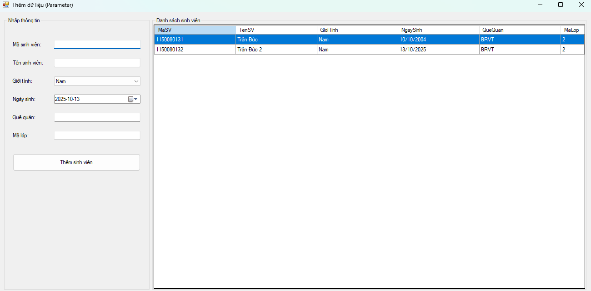

**Form1.cs**

using _1150080131_TranDuc_lab5.Repositories;

using System;

using System.Windows.Forms;

namespace _1150080131_TranDuc_lab5

{

public partial class Form1 : Form

{

private readonly SinhVienRepo _repo = new SinhVienRepo();

public Form1()

{

InitializeComponent();

}

private void Form1_Load(object sender, EventArgs e)

{

cboGioiTinh.Items.Clear();

cboGioiTinh.Items.AddRange(new object[] { "Nam", "Nữ", "Khác" });

cboGioiTinh.SelectedIndex = 0;

dtNgaySinh.Format = DateTimePickerFormat.Custom;

dtNgaySinh.CustomFormat = "yyyy-MM-dd";

LoadGrid();

}

private void LoadGrid()

{

try { dgvSV.DataSource = _repo.GetAll(); }

catch (Exception ex)

{

MessageBox.Show("Lỗi tải dữ liệu: " + ex.Message, "Error",

MessageBoxButtons.OK, MessageBoxIcon.Error);

}

}

private void btnThem_Click(object sender, EventArgs e)

{

if (string.IsNullOrWhiteSpace(txtMaSV.Text) ||

string.IsNullOrWhiteSpace(txtTenSV.Text) ||

string.IsNullOrWhiteSpace(txtMaLop.Text))

{

MessageBox.Show("Nhập Mã SV, Tên SV, Mã lớp.", "Thiếu thông tin",

MessageBoxButtons.OK, MessageBoxIcon.Warning);

return;

}

try

{

var n = _repo.InsertSinhVien(

maSV: txtMaSV.Text,

tenSV: txtTenSV.Text,

gioiTinh: cboGioiTinh.SelectedItem != null ? cboGioiTinh.SelectedItem.ToString() : "",

ngaySinh: dtNgaySinh.Value,

queQuan: txtQueQuan.Text,

maLop: txtMaLop.Text

);

if (n == 1)

{

ClearInputs();

LoadGrid();

MessageBox.Show("Thêm sinh viên thành công!");

}

}

catch (Exception ex)

{

MessageBox.Show("Lỗi thêm: " + ex.Message, "Error",

MessageBoxButtons.OK, MessageBoxIcon.Error);

}

}

private void ClearInputs()

{

txtMaSV.Clear();

txtTenSV.Clear();

cboGioiTinh.SelectedIndex = 0;

dtNgaySinh.Value = DateTime.Today;

txtQueQuan.Clear();

txtMaLop.Clear();

txtMaSV.Focus();

}

}

}

**Form1.Designer.cs**

namespace _1150080131_TranDuc_lab5

{

partial class Form1

{

private System.ComponentModel.IContainer components = null;

private System.Windows.Forms.GroupBox grpNhap;

private System.Windows.Forms.Label label1;

private System.Windows.Forms.TextBox txtMaSV;

private System.Windows.Forms.Label label2;

private System.Windows.Forms.TextBox txtTenSV;

private System.Windows.Forms.Label label3;

private System.Windows.Forms.ComboBox cboGioiTinh;

private System.Windows.Forms.Label label4;

private System.Windows.Forms.DateTimePicker dtNgaySinh;

private System.Windows.Forms.Label label5;

private System.Windows.Forms.TextBox txtQueQuan;

private System.Windows.Forms.Label label6;

private System.Windows.Forms.TextBox txtMaLop;

private System.Windows.Forms.Button btnThem;

private System.Windows.Forms.GroupBox grpDS;

private System.Windows.Forms.DataGridView dgvSV;

protected override void Dispose(bool disposing)

{

if (disposing && (components != null)) components.Dispose();

base.Dispose(disposing);

}

private void InitializeComponent()

{

this.grpNhap = new System.Windows.Forms.GroupBox();

this.btnThem = new System.Windows.Forms.Button();

this.txtMaLop = new System.Windows.Forms.TextBox();

this.label6 = new System.Windows.Forms.Label();

this.txtQueQuan = new System.Windows.Forms.TextBox();

this.label5 = new System.Windows.Forms.Label();

this.dtNgaySinh = new System.Windows.Forms.DateTimePicker();

this.label4 = new System.Windows.Forms.Label();

this.cboGioiTinh = new System.Windows.Forms.ComboBox();

this.label3 = new System.Windows.Forms.Label();

this.txtTenSV = new System.Windows.Forms.TextBox();

this.label2 = new System.Windows.Forms.Label();

this.txtMaSV = new System.Windows.Forms.TextBox();

this.label1 = new System.Windows.Forms.Label();

this.grpDS = new System.Windows.Forms.GroupBox();

this.dgvSV = new System.Windows.Forms.DataGridView();

this.grpNhap.SuspendLayout();

this.grpDS.SuspendLayout();

((System.ComponentModel.ISupportInitialize)(this.dgvSV)).BeginInit();

this.SuspendLayout();

//

// grpNhap

//

this.grpNhap.Anchor = ((System.Windows.Forms.AnchorStyles)(((System.Windows.Forms.AnchorStyles.Top | System.Windows.Forms.AnchorStyles.Bottom)

| System.Windows.Forms.AnchorStyles.Left)));

this.grpNhap.Controls.Add(this.btnThem);

this.grpNhap.Controls.Add(this.txtMaLop);

this.grpNhap.Controls.Add(this.label6);

this.grpNhap.Controls.Add(this.txtQueQuan);

this.grpNhap.Controls.Add(this.label5);

this.grpNhap.Controls.Add(this.dtNgaySinh);

this.grpNhap.Controls.Add(this.label4);

this.grpNhap.Controls.Add(this.cboGioiTinh);

this.grpNhap.Controls.Add(this.label3);

this.grpNhap.Controls.Add(this.txtTenSV);

this.grpNhap.Controls.Add(this.label2);

this.grpNhap.Controls.Add(this.txtMaSV);

this.grpNhap.Controls.Add(this.label1);

this.grpNhap.Location = new System.Drawing.Point(12, 12);

this.grpNhap.Name = "grpNhap";

this.grpNhap.Size = new System.Drawing.Size(320, 600);

this.grpNhap.TabIndex = 0;

this.grpNhap.TabStop = false;

this.grpNhap.Text = "Nhập thông tin";

//

// btnThem

//

this.btnThem.Location = new System.Drawing.Point(19, 300);

this.btnThem.Name = "btnThem";

this.btnThem.Size = new System.Drawing.Size(281, 38);

this.btnThem.TabIndex = 12;

this.btnThem.Text = "Thêm sinh viên";

this.btnThem.UseVisualStyleBackColor = true;

this.btnThem.Click += new System.EventHandler(this.btnThem_Click);

//

// txtMaLop

//

this.txtMaLop.Location = new System.Drawing.Point(110, 250);

this.txtMaLop.Name = "txtMaLop";

this.txtMaLop.Size = new System.Drawing.Size(190, 22);

this.txtMaLop.TabIndex = 6;

//

// label6

//

this.label6.AutoSize = true;

this.label6.Location = new System.Drawing.Point(16, 253);

this.label6.Text = "Mã lớp:";

//

// txtQueQuan

//

this.txtQueQuan.Location = new System.Drawing.Point(110, 210);

this.txtQueQuan.Name = "txtQueQuan";

this.txtQueQuan.Size = new System.Drawing.Size(190, 22);

this.txtQueQuan.TabIndex = 5;

//

// label5

//

this.label5.AutoSize = true;

this.label5.Location = new System.Drawing.Point(16, 213);

this.label5.Text = "Quê quán:";

//

// dtNgaySinh

//

this.dtNgaySinh.Location = new System.Drawing.Point(110, 170);

this.dtNgaySinh.Size = new System.Drawing.Size(190, 22);

//

// label4

//

this.label4.AutoSize = true;

this.label4.Location = new System.Drawing.Point(16, 173);

this.label4.Text = "Ngày sinh:";

//

// cboGioiTinh

//

this.cboGioiTinh.DropDownStyle = System.Windows.Forms.ComboBoxStyle.DropDownList;

this.cboGioiTinh.Location = new System.Drawing.Point(110, 130);

this.cboGioiTinh.Size = new System.Drawing.Size(190, 24);

//

// label3

//

this.label3.AutoSize = true;

this.label3.Location = new System.Drawing.Point(16, 133);

this.label3.Text = "Giới tính:";

//

// txtTenSV

//

this.txtTenSV.Location = new System.Drawing.Point(110, 90);

this.txtTenSV.Size = new System.Drawing.Size(190, 22);

this.txtTenSV.TabIndex = 2;

//

// label2

//

this.label2.AutoSize = true;

this.label2.Location = new System.Drawing.Point(16, 93);

this.label2.Text = "Tên sinh viên:";

//

// txtMaSV

//

this.txtMaSV.Location = new System.Drawing.Point(110, 50);

this.txtMaSV.Size = new System.Drawing.Size(190, 22);

this.txtMaSV.TabIndex = 1;

//

// label1

//

this.label1.AutoSize = true;

this.label1.Location = new System.Drawing.Point(16, 53);

this.label1.Text = "Mã sinh viên:";

//

// grpDS

//

this.grpDS.Anchor = ((System.Windows.Forms.AnchorStyles)((((System.Windows.Forms.AnchorStyles.Top | System.Windows.Forms.AnchorStyles.Bottom)

| System.Windows.Forms.AnchorStyles.Left)

| System.Windows.Forms.AnchorStyles.Right)));

this.grpDS.Controls.Add(this.dgvSV);

this.grpDS.Location = new System.Drawing.Point(338, 12);

this.grpDS.Name = "grpDS";

this.grpDS.Size = new System.Drawing.Size(930, 600);

this.grpDS.TabIndex = 1;

this.grpDS.TabStop = false;

this.grpDS.Text = "Danh sách sinh viên";

//

// dgvSV

//

this.dgvSV.AllowUserToAddRows = false;

this.dgvSV.AllowUserToDeleteRows = false;

this.dgvSV.AutoSizeColumnsMode = System.Windows.Forms.DataGridViewAutoSizeColumnsMode.Fill;

this.dgvSV.BackgroundColor = System.Drawing.SystemColors.Window;

this.dgvSV.Dock = System.Windows.Forms.DockStyle.Fill;

this.dgvSV.ReadOnly = true;

this.dgvSV.RowHeadersVisible = false;

this.dgvSV.SelectionMode = System.Windows.Forms.DataGridViewSelectionMode.FullRowSelect;

this.dgvSV.Name = "dgvSV";

//

// Form1

//

this.AutoScaleDimensions = new System.Drawing.SizeF(8F, 16F);

this.ClientSize = new System.Drawing.Size(1280, 624);

this.Controls.Add(this.grpDS);

this.Controls.Add(this.grpNhap);

this.Name = "Form1";

this.StartPosition = System.Windows.Forms.FormStartPosition.CenterScreen;

this.Text = "Thêm dữ liệu (Parameter)";

this.Load += new System.EventHandler(this.Form1_Load);

this.grpNhap.ResumeLayout(false);

this.grpNhap.PerformLayout();

this.grpDS.ResumeLayout(false);

((System.ComponentModel.ISupportInitialize)(this.dgvSV)).EndInit();

this.ResumeLayout(false);

}

}

}

**SinhVienRepo.cs**

using System;

using System.Configuration;

using System.Data;

using System.Data.SqlClient;

namespace _1150080131_TranDuc_lab5.Repositories

{

public class SinhVienRepo

{

private readonly string _connStr =

ConfigurationManager.ConnectionStrings["QLSV"].ConnectionString;

public int InsertSinhVien(string maSV, string tenSV, string gioiTinh,

DateTime ngaySinh, string queQuan, string maLop)

{

const string SQL = @"

INSERT INTO dbo.SinhVien (MaSV, TenSV, GioiTinh, NgaySinh, QueQuan, MaLop)

VALUES (@MaSV, @TenSV, @GioiTinh, @NgaySinh, @QueQuan, @MaLop);";

using (var conn = new SqlConnection(_connStr))

using (var cmd = new SqlCommand(SQL, conn))

{

cmd.Parameters.Add(new SqlParameter("@MaSV", SqlDbType.VarChar, 20) { Value = maSV.Trim() });

cmd.Parameters.Add(new SqlParameter("@TenSV", SqlDbType.NVarChar, 100) { Value = tenSV.Trim() });

cmd.Parameters.Add(new SqlParameter("@GioiTinh", SqlDbType.NVarChar, 10) { Value = gioiTinh });

cmd.Parameters.Add(new SqlParameter("@NgaySinh", SqlDbType.Date) { Value = ngaySinh.Date });

cmd.Parameters.Add(new SqlParameter("@QueQuan", SqlDbType.NVarChar, 100)

{ Value = string.IsNullOrWhiteSpace(queQuan) ? (object)DBNull.Value : queQuan.Trim() });

cmd.Parameters.Add(new SqlParameter("@MaLop", SqlDbType.VarChar, 20) { Value = maLop.Trim() });

conn.Open();

return cmd.ExecuteNonQuery(); // 1 nếu thêm thành công

}

}

public DataTable GetAll()

{

const string SQL = @"SELECT MaSV, TenSV, GioiTinh, NgaySinh, QueQuan, MaLop

FROM dbo.SinhVien ORDER BY MaSV;";

using (var conn = new SqlConnection(_connStr))

using (var da = new SqlDataAdapter(SQL, conn))

{

var dt = new DataTable();

da.Fill(dt);

return dt;

}

}

}

}

**Thực hành 3: Sửa dữ liệu không dùng Parameter.**

− Sử dụng hàm ExecuteNonQuery để thực hiện sửa dữ liệu.

− Ví dụ: Sửa dữ liệu cho 1 sinh viên trong bảng SinhVien.

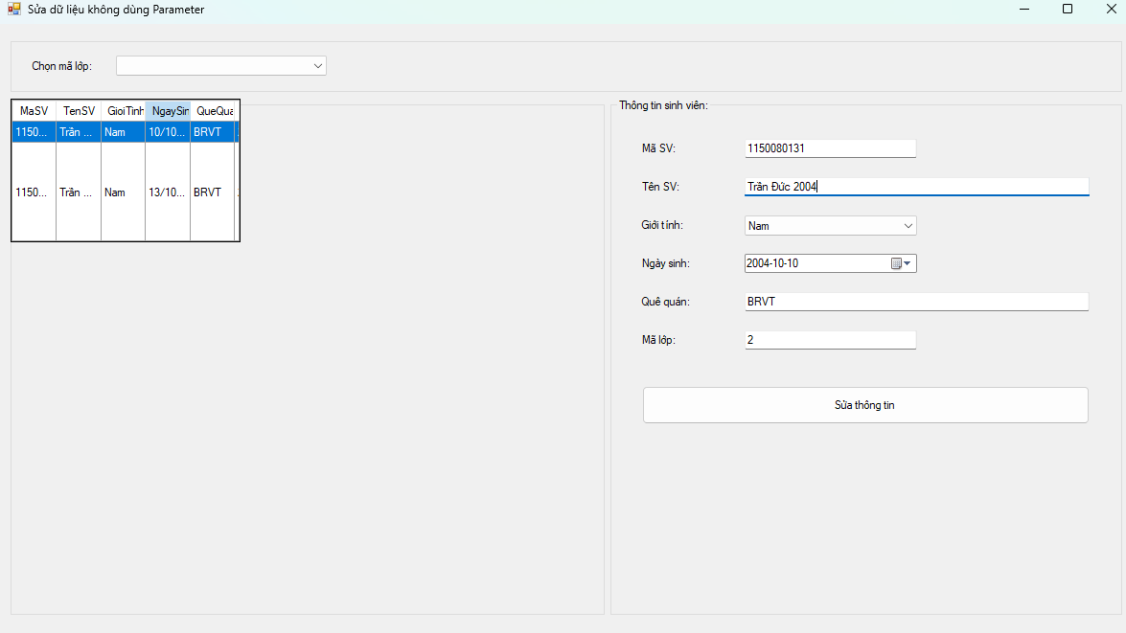

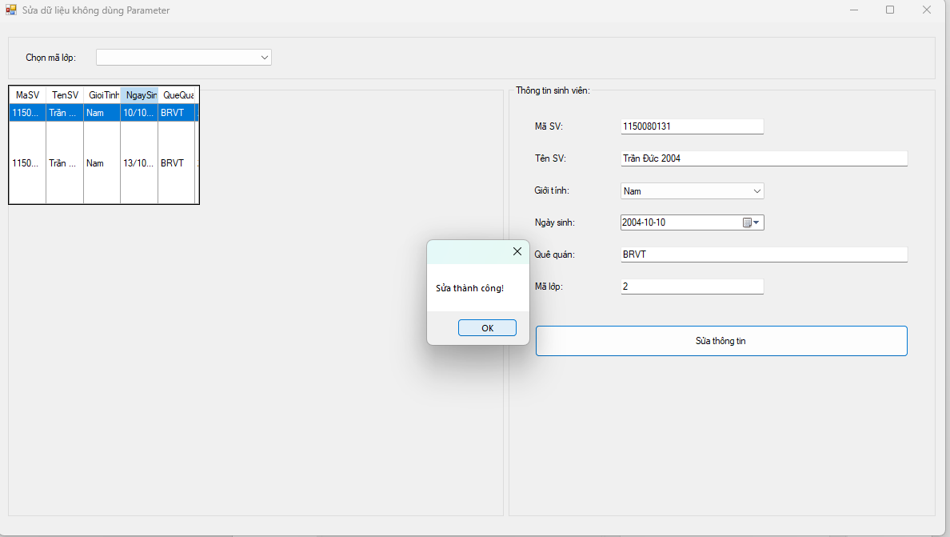

**Form2.cs**

using System;

using System.Configuration;

using System.Data;

using System.Data.SqlClient;

using System.Text;

using System.Windows.Forms;

namespace _1150080131_TranDuc_lab5

{

public partial class Form2 : Form

{

// lấy từ App.config, nếu thiếu thì dùng chuỗi fallback

private readonly string _connStr =

ConfigurationManager.ConnectionStrings["QLSV"]?.ConnectionString

?? @"Data Source=LAPTOP-LQGGA8E3\MSSQLSERVER2;Initial Catalog=QLSV;Integrated Security=True;Persist Security Info=False;TrustServerCertificate=True";

private string _originalMaSV = ""; // giữ MaSV gốc khi sửa

public Form2()

{

InitializeComponent();

}

private SqlConnection Conn() => new SqlConnection(_connStr);

private void Form2_Load(object sender, EventArgs e)

{

// format ngày

dtNgaySinh.Format = DateTimePickerFormat.Custom;

dtNgaySinh.CustomFormat = "yyyy-MM-dd";

// combobox giới tính

cboGioiTinh.Items.Clear();

cboGioiTinh.Items.AddRange(new object[] { "Nam", "Nữ", "Khác" });

cboGioiTinh.SelectedIndex = 0;

LoadLop();

LoadGrid(null);

}

private void LoadLop()

{

const string sql = "SELECT MaLop FROM dbo.Lop ORDER BY MaLop;";

using (var da = new SqlDataAdapter(sql, Conn()))

{

var dt = new DataTable();

da.Fill(dt);

cboLop.DataSource = dt;

cboLop.DisplayMember = "MaLop";

cboLop.ValueMember = "MaLop";

cboLop.SelectedIndex = -1; // xem tất cả khi mới mở

}

}

private void LoadGrid(string maLop)

{

string sql = string.IsNullOrWhiteSpace(maLop)

? @"SELECT MaSV, TenSV, GioiTinh, NgaySinh, QueQuan, MaLop

FROM dbo.SinhVien ORDER BY MaSV;"

: $@"SELECT MaSV, TenSV, GioiTinh, NgaySinh, QueQuan, MaLop

FROM dbo.SinhVien WHERE MaLop = '{Esc(maLop)}' ORDER BY MaSV;";

using (var da = new SqlDataAdapter(sql, Conn()))

{

var dt = new DataTable();

da.Fill(dt);

dgvSV.DataSource = dt;

}

}

private static string Esc(string s) => (s ?? string.Empty).Replace("'", "''"); // escape đơn giản

private void cboLop_SelectionChangeCommitted(object sender, EventArgs e)

{

LoadGrid(cboLop.SelectedValue?.ToString());

ClearInputs();

}

private void dgvSV_CellClick(object sender, DataGridViewCellEventArgs e)

{

if (e.RowIndex < 0) return;

var row = dgvSV.Rows[e.RowIndex];

_originalMaSV = row.Cells["MaSV"].Value?.ToString() ?? "";

txtMaSV.Text = _originalMaSV;

txtTenSV.Text = row.Cells["TenSV"].Value?.ToString();

cboGioiTinh.Text = row.Cells["GioiTinh"].Value?.ToString() ?? "Nam";

txtQueQuan.Text = row.Cells["QueQuan"].Value?.ToString();

txtMaLop.Text = row.Cells["MaLop"].Value?.ToString();

if (DateTime.TryParse(row.Cells["NgaySinh"].Value?.ToString(), out var d))

dtNgaySinh.Value = d;

}

private void btnSua_Click(object sender, EventArgs e)

{

if (string.IsNullOrWhiteSpace(_originalMaSV))

{

MessageBox.Show("Hãy chọn một sinh viên ở danh sách bên trái.");

return;

}

if (string.IsNullOrWhiteSpace(txtMaSV.Text) ||

string.IsNullOrWhiteSpace(txtTenSV.Text) ||

string.IsNullOrWhiteSpace(txtMaLop.Text))

{

MessageBox.Show("Mã SV, Tên SV, Mã lớp không được trống.");

return;

}

// GHÍ CHÚ: theo yêu cầu bài, KHÔNG dùng parameter → nối chuỗi

string que = string.IsNullOrWhiteSpace(txtQueQuan.Text)

? "NULL" : $"N'{Esc(txtQueQuan.Text)}'";

var sb = new StringBuilder();

sb.Append("UPDATE dbo.SinhVien SET ");

sb.Append($"MaSV='{Esc(txtMaSV.Text)}', ");

sb.Append($"TenSV=N'{Esc(txtTenSV.Text)}', ");

sb.Append($"GioiTinh=N'{Esc(cboGioiTinh.Text)}', ");

sb.Append($"NgaySinh='{dtNgaySinh.Value:yyyy-MM-dd}', ");

sb.Append($"QueQuan={que}, ");

sb.Append($"MaLop='{Esc(txtMaLop.Text)}' ");

sb.Append($"WHERE MaSV='{Esc(_originalMaSV)}';");

try

{

using (var conn = Conn())

using (var cmd = new SqlCommand(sb.ToString(), conn))

{

conn.Open();

int n = cmd.ExecuteNonQuery(); // Sửa dữ liệu: ExecuteNonQuery

if (n == 1)

{

MessageBox.Show("Sửa thành công!");

LoadGrid(cboLop.SelectedIndex >= 0 ? cboLop.SelectedValue?.ToString() : null);

}

else

{

MessageBox.Show("Không có bản ghi nào được cập nhật.");

}

}

}

catch (Exception ex)

{

MessageBox.Show("Lỗi sửa dữ liệu: " + ex.Message, "Error",

MessageBoxButtons.OK, MessageBoxIcon.Error);

}

}

private void ClearInputs()

{

_originalMaSV = "";

txtMaSV.Clear();

txtTenSV.Clear();

cboGioiTinh.SelectedIndex = 0;

dtNgaySinh.Value = DateTime.Today;

txtQueQuan.Clear();

txtMaLop.Clear();

}

}

}

**Form2.Desginer.cs**

namespace _1150080131_TranDuc_lab5

{

partial class Form2

{

private System.ComponentModel.IContainer components = null;

private System.Windows.Forms.GroupBox grpTop;

private System.Windows.Forms.Label lblChonLop;

private System.Windows.Forms.ComboBox cboLop;

private System.Windows.Forms.GroupBox grpLeft;

private System.Windows.Forms.DataGridView dgvSV;

private System.Windows.Forms.GroupBox grpRight;

private System.Windows.Forms.Label label1;

private System.Windows.Forms.TextBox txtMaSV;

private System.Windows.Forms.Label label2;

private System.Windows.Forms.TextBox txtTenSV;

private System.Windows.Forms.Label label3;

private System.Windows.Forms.ComboBox cboGioiTinh;

private System.Windows.Forms.Label label4;

private System.Windows.Forms.DateTimePicker dtNgaySinh;

private System.Windows.Forms.Label label5;

private System.Windows.Forms.TextBox txtQueQuan;

private System.Windows.Forms.Label label6;

private System.Windows.Forms.TextBox txtMaLop;

private System.Windows.Forms.Button btnSua;

protected override void Dispose(bool disposing)

{

if (disposing && (components != null)) components.Dispose();

base.Dispose(disposing);

}

private void InitializeComponent()

{

this.grpTop = new System.Windows.Forms.GroupBox();

this.lblChonLop = new System.Windows.Forms.Label();

this.cboLop = new System.Windows.Forms.ComboBox();

this.grpLeft = new System.Windows.Forms.GroupBox();

this.dgvSV = new System.Windows.Forms.DataGridView();

this.grpRight = new System.Windows.Forms.GroupBox();

this.btnSua = new System.Windows.Forms.Button();

this.txtMaLop = new System.Windows.Forms.TextBox();

this.label6 = new System.Windows.Forms.Label();

this.txtQueQuan = new System.Windows.Forms.TextBox();

this.label5 = new System.Windows.Forms.Label();

this.dtNgaySinh = new System.Windows.Forms.DateTimePicker();

this.label4 = new System.Windows.Forms.Label();

this.cboGioiTinh = new System.Windows.Forms.ComboBox();

this.label3 = new System.Windows.Forms.Label();

this.txtTenSV = new System.Windows.Forms.TextBox();

this.label2 = new System.Windows.Forms.Label();

this.txtMaSV = new System.Windows.Forms.TextBox();

this.label1 = new System.Windows.Forms.Label();

this.grpTop.SuspendLayout();

this.grpLeft.SuspendLayout();

((System.ComponentModel.ISupportInitialize)(this.dgvSV)).BeginInit();

this.grpRight.SuspendLayout();

this.SuspendLayout();

//

// grpTop

//

this.grpTop.Anchor = ((System.Windows.Forms.AnchorStyles)(((System.Windows.Forms.AnchorStyles.Top | System.Windows.Forms.AnchorStyles.Left)

| System.Windows.Forms.AnchorStyles.Right)));

this.grpTop.Controls.Add(this.cboLop);

this.grpTop.Controls.Add(this.lblChonLop);

this.grpTop.Location = new System.Drawing.Point(12, 12);

this.grpTop.Name = "grpTop";

this.grpTop.Size = new System.Drawing.Size(1160, 60);

this.grpTop.TabIndex = 0;

this.grpTop.TabStop = false;

//

// lblChonLop

//

this.lblChonLop.AutoSize = true;

this.lblChonLop.Location = new System.Drawing.Point(20, 25);

this.lblChonLop.Text = "Chọn mã lớp:";

//

// cboLop

//

this.cboLop.DropDownStyle = System.Windows.Forms.ComboBoxStyle.DropDownList;

this.cboLop.Location = new System.Drawing.Point(110, 21);

this.cboLop.Size = new System.Drawing.Size(220, 24);

this.cboLop.SelectionChangeCommitted += new System.EventHandler(this.cboLop_SelectionChangeCommitted);

//

// grpLeft

//

this.grpLeft.Anchor = ((System.Windows.Forms.AnchorStyles)(((System.Windows.Forms.AnchorStyles.Top | System.Windows.Forms.AnchorStyles.Bottom)

| System.Windows.Forms.AnchorStyles.Left)));

this.grpLeft.Controls.Add(this.dgvSV);

this.grpLeft.Location = new System.Drawing.Point(12, 78);

this.grpLeft.Name = "grpLeft";

this.grpLeft.Size = new System.Drawing.Size(620, 540);

this.grpLeft.TabIndex = 1;

this.grpLeft.TabStop = false;

this.grpLeft.Text = "Danh sách sinh viên:";

//

// dgvSV

//

this.dgvSV.AllowUserToAddRows = false;

this.dgvSV.AllowUserToDeleteRows = false;

this.dgvSV.AutoSizeColumnsMode = System.Windows.Forms.DataGridViewAutoSizeColumnsMode.Fill;

this.dgvSV.BackgroundColor = System.Drawing.SystemColors.Window;

this.dgvSV.Dock = System.Windows.Forms.DockStyle.Fill;

this.dgvSV.ReadOnly = true;

this.dgvSV.RowHeadersVisible = false;

this.dgvSV.SelectionMode = System.Windows.Forms.DataGridViewSelectionMode.FullRowSelect;

this.dgvSV.CellClick += new System.Windows.Forms.DataGridViewCellEventHandler(this.dgvSV_CellClick);

//

// grpRight

//

this.grpRight.Anchor = ((System.Windows.Forms.AnchorStyles)(((System.Windows.Forms.AnchorStyles.Top | System.Windows.Forms.AnchorStyles.Bottom)

| System.Windows.Forms.AnchorStyles.Right)));

this.grpRight.Controls.Add(this.btnSua);

this.grpRight.Controls.Add(this.txtMaLop);

this.grpRight.Controls.Add(this.label6);

this.grpRight.Controls.Add(this.txtQueQuan);

this.grpRight.Controls.Add(this.label5);

this.grpRight.Controls.Add(this.dtNgaySinh);

this.grpRight.Controls.Add(this.label4);

this.grpRight.Controls.Add(this.cboGioiTinh);

this.grpRight.Controls.Add(this.label3);

this.grpRight.Controls.Add(this.txtTenSV);

this.grpRight.Controls.Add(this.label2);

this.grpRight.Controls.Add(this.txtMaSV);

this.grpRight.Controls.Add(this.label1);

this.grpRight.Location = new System.Drawing.Point(638, 78);

this.grpRight.Name = "grpRight";

this.grpRight.Size = new System.Drawing.Size(534, 540);

this.grpRight.TabIndex = 2;

this.grpRight.TabStop = false;

this.grpRight.Text = "Thông tin sinh viên:";

//

// label1..btnSua

//

this.label1.AutoSize = true; this.label1.Location = new System.Drawing.Point(30, 45); this.label1.Text = "Mã SV:";

this.txtMaSV.Location = new System.Drawing.Point(140, 42); this.txtMaSV.Size = new System.Drawing.Size(180, 22);

this.label2.AutoSize = true; this.label2.Location = new System.Drawing.Point(30, 85); this.label2.Text = "Tên SV:";

this.txtTenSV.Location = new System.Drawing.Point(140, 82); this.txtTenSV.Size = new System.Drawing.Size(360, 22);

this.label3.AutoSize = true; this.label3.Location = new System.Drawing.Point(30, 125); this.label3.Text = "Giới tính:";

this.cboGioiTinh.DropDownStyle = System.Windows.Forms.ComboBoxStyle.DropDownList;

this.cboGioiTinh.Items.AddRange(new object[] { "Nam", "Nữ", "Khác" });

this.cboGioiTinh.Location = new System.Drawing.Point(140, 122); this.cboGioiTinh.Size = new System.Drawing.Size(180, 24);

this.label4.AutoSize = true; this.label4.Location = new System.Drawing.Point(30, 165); this.label4.Text = "Ngày sinh:";

this.dtNgaySinh.Location = new System.Drawing.Point(140, 162); this.dtNgaySinh.Size = new System.Drawing.Size(180, 22);

this.label5.AutoSize = true; this.label5.Location = new System.Drawing.Point(30, 205); this.label5.Text = "Quê quán:";

this.txtQueQuan.Location = new System.Drawing.Point(140, 202); this.txtQueQuan.Size = new System.Drawing.Size(360, 22);

this.label6.AutoSize = true; this.label6.Location = new System.Drawing.Point(30, 245); this.label6.Text = "Mã lớp:";

this.txtMaLop.Location = new System.Drawing.Point(140, 242); this.txtMaLop.Size = new System.Drawing.Size(180, 22);

this.btnSua.Location = new System.Drawing.Point(33, 300);

this.btnSua.Size = new System.Drawing.Size(467, 40);

this.btnSua.Text = "Sửa thông tin";

this.btnSua.Click += new System.EventHandler(this.btnSua_Click);

//

// Form2

//

this.AutoScaleDimensions = new System.Drawing.SizeF(8F, 16F);

this.ClientSize = new System.Drawing.Size(1184, 641);

this.Controls.Add(this.grpRight);

this.Controls.Add(this.grpLeft);

this.Controls.Add(this.grpTop);

this.Name = "Form2";

this.StartPosition = System.Windows.Forms.FormStartPosition.CenterScreen;

this.Text = "Sửa dữ liệu không dùng Parameter";

this.Load += new System.EventHandler(this.Form2_Load);

this.grpTop.ResumeLayout(false);

this.grpTop.PerformLayout();

this.grpLeft.ResumeLayout(false);

((System.ComponentModel.ISupportInitialize)(this.dgvSV)).EndInit();

this.grpRight.ResumeLayout(false);

this.grpRight.PerformLayout();

this.ResumeLayout(false);

}

}

}

**Áp dụng 2: Sửa dữ liệu có dùng Parameter.**

Cũng sửa dữ liệu cho 1 sinh viên vào bảng SinhVien như ví dụ trên. Tuy nhiên,

trong chương trình có sử dụng các Parameter.

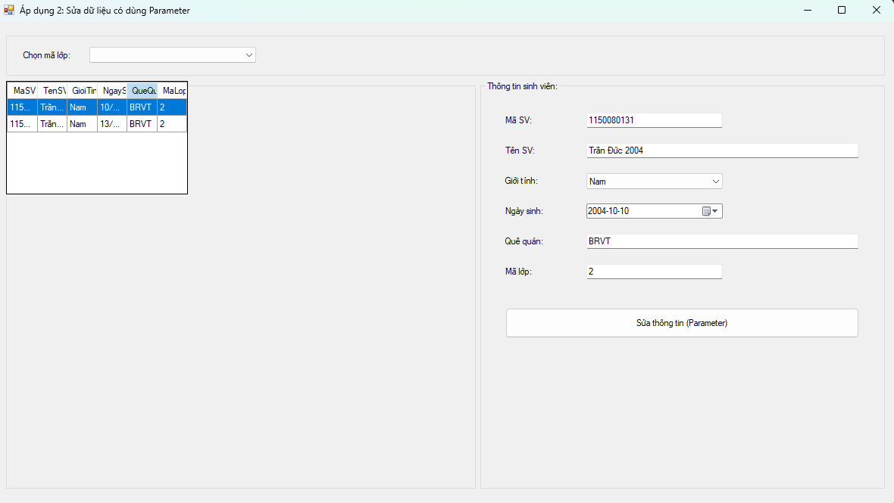

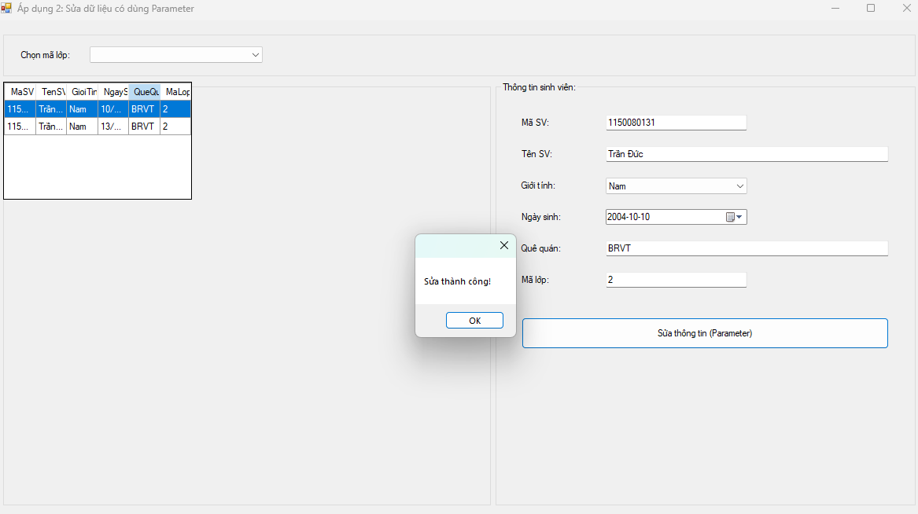

**Form2.cs**

using System;

using System.Configuration;

using System.Data;

using System.Data.SqlClient;

using System.Drawing;

using System.Windows.Forms;

namespace _1150080131_TranDuc_lab5

{

public partial class Form3 : Form

{

private readonly string _connStr =

ConfigurationManager.ConnectionStrings["QLSV"]?.ConnectionString

?? @"Data Source=LAPTOP-LQGGA8E3\MSSQLSERVER2;Initial Catalog=QLSV;Integrated Security=True;Persist Security Info=False;TrustServerCertificate=True";

private string _originalMaSV = ""; // giữ MaSV gốc để WHERE khi cho phép đổi MaSV

public Form3()

{

InitializeComponent();

}

private SqlConnection Conn() => new SqlConnection(_connStr);

private void Form3_Load(object sender, EventArgs e)

{

// Combobox giới tính

cboGioiTinh.Items.Clear();

cboGioiTinh.Items.AddRange(new object[] { "Nam", "Nữ", "Khác" });

cboGioiTinh.SelectedIndex = 0;

// Combobox lớp

LoadLop();

// Ngày sinh

dtNgaySinh.Format = DateTimePickerFormat.Custom;

dtNgaySinh.CustomFormat = "yyyy-MM-dd";

LoadGrid(null);

}

private void LoadLop()

{

const string sql = "SELECT MaLop FROM dbo.Lop ORDER BY MaLop;";

using (var da = new SqlDataAdapter(sql, Conn()))

{

var dt = new DataTable();

da.Fill(dt);

cboLop.DataSource = dt;

cboLop.DisplayMember = "MaLop";

cboLop.ValueMember = "MaLop";

cboLop.SelectedIndex = -1; // xem tất cả

}

}

private void LoadGrid(string maLop)

{

var sql = @"SELECT MaSV, TenSV, GioiTinh, NgaySinh, QueQuan, MaLop

FROM dbo.SinhVien {0} ORDER BY MaSV;";

var where = string.IsNullOrWhiteSpace(maLop) ? "" : "WHERE MaLop = @MaLop";

using (var conn = Conn())

using (var cmd = new SqlCommand(string.Format(sql, where), conn))

{

if (!string.IsNullOrWhiteSpace(maLop))

cmd.Parameters.Add(new SqlParameter("@MaLop", SqlDbType.VarChar, 20) { Value = maLop });

using (var da = new SqlDataAdapter(cmd))

{

var dt = new DataTable();

da.Fill(dt);

dgvSV.DataSource = dt;

}

}

}

private void cboLop_SelectionChangeCommitted(object sender, EventArgs e)

{

LoadGrid(cboLop.SelectedValue?.ToString());

ClearInputs();

}

private void dgvSV_CellClick(object sender, DataGridViewCellEventArgs e)

{

if (e.RowIndex < 0) return;

var row = dgvSV.Rows[e.RowIndex];

_originalMaSV = row.Cells["MaSV"].Value?.ToString() ?? "";

txtMaSV.Text = _originalMaSV;

txtTenSV.Text = row.Cells["TenSV"].Value?.ToString();

cboGioiTinh.Text = row.Cells["GioiTinh"].Value?.ToString() ?? "Nam";

txtQueQuan.Text = row.Cells["QueQuan"].Value?.ToString();

txtMaLop.Text = row.Cells["MaLop"].Value?.ToString();

if (DateTime.TryParse(row.Cells["NgaySinh"].Value?.ToString(), out var d))

dtNgaySinh.Value = d;

}

private void btnSua_Click(object sender, EventArgs e)

{

if (string.IsNullOrWhiteSpace(_originalMaSV))

{

MessageBox.Show("Hãy chọn một sinh viên ở danh sách.");

return;

}

if (string.IsNullOrWhiteSpace(txtMaSV.Text) ||

string.IsNullOrWhiteSpace(txtTenSV.Text) ||

string.IsNullOrWhiteSpace(txtMaLop.Text))

{

MessageBox.Show("Mã SV, Tên SV, Mã lớp không được trống.");

return;

}

const string SQL = @"

UPDATE dbo.SinhVien

SET MaSV=@MaSV, TenSV=@TenSV, GioiTinh=@GioiTinh, NgaySinh=@NgaySinh,

QueQuan=@QueQuan, MaLop=@MaLop

WHERE MaSV=@OriginalMaSV;";

try

{

using (var conn = Conn())

using (var cmd = new SqlCommand(SQL, conn))

{

cmd.Parameters.Add(new SqlParameter("@MaSV", SqlDbType.VarChar, 20) { Value = txtMaSV.Text.Trim() });

cmd.Parameters.Add(new SqlParameter("@TenSV", SqlDbType.NVarChar, 100) { Value = txtTenSV.Text.Trim() });

cmd.Parameters.Add(new SqlParameter("@GioiTinh", SqlDbType.NVarChar, 10) { Value = cboGioiTinh.Text });

cmd.Parameters.Add(new SqlParameter("@NgaySinh", SqlDbType.Date) { Value = dtNgaySinh.Value.Date });

// cho phép null

var q = string.IsNullOrWhiteSpace(txtQueQuan.Text) ? (object)DBNull.Value : txtQueQuan.Text.Trim();

cmd.Parameters.Add(new SqlParameter("@QueQuan", SqlDbType.NVarChar, 100) { Value = q });

cmd.Parameters.Add(new SqlParameter("@MaLop", SqlDbType.VarChar, 20) { Value = txtMaLop.Text.Trim() });

cmd.Parameters.Add(new SqlParameter("@OriginalMaSV", SqlDbType.VarChar, 20) { Value = _originalMaSV });

conn.Open();

int n = cmd.ExecuteNonQuery(); // dùng ExecuteNonQuery

if (n == 1)

{

MessageBox.Show("Sửa thành công!");

LoadGrid(cboLop.SelectedIndex >= 0 ? cboLop.SelectedValue?.ToString() : null);

_originalMaSV = txtMaSV.Text.Trim(); // cập nhật khoá gốc nếu bạn vừa đổi MaSV

}

else

{

MessageBox.Show("Không có bản ghi nào được cập nhật.");

}

}

}

catch (SqlException ex)

{

MessageBox.Show("SQL lỗi: " + ex.Message);

}

catch (Exception ex)

{

MessageBox.Show("Lỗi: " + ex.Message);

}

}

private void ClearInputs()

{

_originalMaSV = "";

txtMaSV.Clear();

txtTenSV.Clear();

cboGioiTinh.SelectedIndex = 0;

dtNgaySinh.Value = DateTime.Today;

txtQueQuan.Clear();

txtMaLop.Clear();

}

}

}

**Form3.Desginer.cs**

namespace _1150080131_TranDuc_lab5

{

partial class Form3

{

private System.ComponentModel.IContainer components = null;

private System.Windows.Forms.GroupBox grpTop;

private System.Windows.Forms.Label lblChonLop;

private System.Windows.Forms.ComboBox cboLop;

private System.Windows.Forms.GroupBox grpLeft;

private System.Windows.Forms.DataGridView dgvSV;

private System.Windows.Forms.GroupBox grpRight;

private System.Windows.Forms.Label label1;

private System.Windows.Forms.TextBox txtMaSV;

private System.Windows.Forms.Label label2;

private System.Windows.Forms.TextBox txtTenSV;

private System.Windows.Forms.Label label3;

private System.Windows.Forms.ComboBox cboGioiTinh;

private System.Windows.Forms.Label label4;

private System.Windows.Forms.DateTimePicker dtNgaySinh;

private System.Windows.Forms.Label label5;

private System.Windows.Forms.TextBox txtQueQuan;

private System.Windows.Forms.Label label6;

private System.Windows.Forms.TextBox txtMaLop;

private System.Windows.Forms.Button btnSua;

protected override void Dispose(bool disposing)

{

if (disposing && (components != null)) components.Dispose();

base.Dispose(disposing);

}

private void InitializeComponent()

{

this.grpTop = new System.Windows.Forms.GroupBox();

this.lblChonLop = new System.Windows.Forms.Label();

this.cboLop = new System.Windows.Forms.ComboBox();

this.grpLeft = new System.Windows.Forms.GroupBox();

this.dgvSV = new System.Windows.Forms.DataGridView();

this.grpRight = new System.Windows.Forms.GroupBox();

this.btnSua = new System.Windows.Forms.Button();

this.txtMaLop = new System.Windows.Forms.TextBox();

this.label6 = new System.Windows.Forms.Label();

this.txtQueQuan = new System.Windows.Forms.TextBox();

this.label5 = new System.Windows.Forms.Label();

this.dtNgaySinh = new System.Windows.Forms.DateTimePicker();

this.label4 = new System.Windows.Forms.Label();

this.cboGioiTinh = new System.Windows.Forms.ComboBox();

this.label3 = new System.Windows.Forms.Label();

this.txtTenSV = new System.Windows.Forms.TextBox();

this.label2 = new System.Windows.Forms.Label();

this.txtMaSV = new System.Windows.Forms.TextBox();

this.label1 = new System.Windows.Forms.Label();

this.grpTop.SuspendLayout();

this.grpLeft.SuspendLayout();

((System.ComponentModel.ISupportInitialize)(this.dgvSV)).BeginInit();

this.grpRight.SuspendLayout();

this.SuspendLayout();

//

// grpTop

//

this.grpTop.Anchor = ((System.Windows.Forms.AnchorStyles)(((System.Windows.Forms.AnchorStyles.Top | System.Windows.Forms.AnchorStyles.Left)

| System.Windows.Forms.AnchorStyles.Right)));

this.grpTop.Controls.Add(this.cboLop);

this.grpTop.Controls.Add(this.lblChonLop);

this.grpTop.Location = new System.Drawing.Point(12, 12);

this.grpTop.Name = "grpTop";

this.grpTop.Size = new System.Drawing.Size(1160, 60);

this.grpTop.TabIndex = 0;

this.grpTop.TabStop = false;

//

// lblChonLop

//

this.lblChonLop.AutoSize = true;

this.lblChonLop.Location = new System.Drawing.Point(20, 25);

this.lblChonLop.Text = "Chọn mã lớp:";

//

// cboLop

//

this.cboLop.DropDownStyle = System.Windows.Forms.ComboBoxStyle.DropDownList;

this.cboLop.Location = new System.Drawing.Point(110, 21);

this.cboLop.Size = new System.Drawing.Size(220, 24);

this.cboLop.SelectionChangeCommitted += new System.EventHandler(this.cboLop_SelectionChangeCommitted);

//

// grpLeft

//

this.grpLeft.Anchor = ((System.Windows.Forms.AnchorStyles)(((System.Windows.Forms.AnchorStyles.Top | System.Windows.Forms.AnchorStyles.Bottom)

| System.Windows.Forms.AnchorStyles.Left)));

this.grpLeft.Controls.Add(this.dgvSV);

this.grpLeft.Location = new System.Drawing.Point(12, 78);

this.grpLeft.Name = "grpLeft";

this.grpLeft.Size = new System.Drawing.Size(620, 540);

this.grpLeft.TabIndex = 1;

this.grpLeft.TabStop = false;

this.grpLeft.Text = "Danh sách sinh viên:";

//

// dgvSV

//

this.dgvSV.AllowUserToAddRows = false;

this.dgvSV.AllowUserToDeleteRows = false;

this.dgvSV.AutoSizeColumnsMode = System.Windows.Forms.DataGridViewAutoSizeColumnsMode.Fill;

this.dgvSV.BackgroundColor = System.Drawing.SystemColors.Window;

this.dgvSV.Dock = System.Windows.Forms.DockStyle.Fill;

this.dgvSV.ReadOnly = true;

this.dgvSV.RowHeadersVisible = false;

this.dgvSV.SelectionMode = System.Windows.Forms.DataGridViewSelectionMode.FullRowSelect;

this.dgvSV.CellClick += new System.Windows.Forms.DataGridViewCellEventHandler(this.dgvSV_CellClick);

//

// grpRight

//

this.grpRight.Anchor = ((System.Windows.Forms.AnchorStyles)(((System.Windows.Forms.AnchorStyles.Top | System.Windows.Forms.AnchorStyles.Bottom)

| System.Windows.Forms.AnchorStyles.Right)));

this.grpRight.Controls.Add(this.btnSua);

this.grpRight.Controls.Add(this.txtMaLop);

this.grpRight.Controls.Add(this.label6);

this.grpRight.Controls.Add(this.txtQueQuan);

this.grpRight.Controls.Add(this.label5);

this.grpRight.Controls.Add(this.dtNgaySinh);

this.grpRight.Controls.Add(this.label4);

this.grpRight.Controls.Add(this.cboGioiTinh);

this.grpRight.Controls.Add(this.label3);

this.grpRight.Controls.Add(this.txtTenSV);

this.grpRight.Controls.Add(this.label2);

this.grpRight.Controls.Add(this.txtMaSV);

this.grpRight.Controls.Add(this.label1);

this.grpRight.Location = new System.Drawing.Point(638, 78);

this.grpRight.Name = "grpRight";

this.grpRight.Size = new System.Drawing.Size(534, 540);

this.grpRight.TabIndex = 2;

this.grpRight.TabStop = false;

this.grpRight.Text = "Thông tin sinh viên:";

//

// label1..btnSua

//

this.label1.AutoSize = true; this.label1.Location = new System.Drawing.Point(30, 45); this.label1.Text = "Mã SV:";

this.txtMaSV.Location = new System.Drawing.Point(140, 42); this.txtMaSV.Size = new System.Drawing.Size(180, 22);

this.label2.AutoSize = true; this.label2.Location = new System.Drawing.Point(30, 85); this.label2.Text = "Tên SV:";

this.txtTenSV.Location = new System.Drawing.Point(140, 82); this.txtTenSV.Size = new System.Drawing.Size(360, 22);

this.label3.AutoSize = true; this.label3.Location = new System.Drawing.Point(30, 125); this.label3.Text = "Giới tính:";

this.cboGioiTinh.DropDownStyle = System.Windows.Forms.ComboBoxStyle.DropDownList;

this.cboGioiTinh.Items.AddRange(new object[] { "Nam", "Nữ", "Khác" });

this.cboGioiTinh.Location = new System.Drawing.Point(140, 122); this.cboGioiTinh.Size = new System.Drawing.Size(180, 24);

this.label4.AutoSize = true; this.label4.Location = new System.Drawing.Point(30, 165); this.label4.Text = "Ngày sinh:";

this.dtNgaySinh.Location = new System.Drawing.Point(140, 162); this.dtNgaySinh.Size = new System.Drawing.Size(180, 22);

this.label5.AutoSize = true; this.label5.Location = new System.Drawing.Point(30, 205); this.label5.Text = "Quê quán:";

this.txtQueQuan.Location = new System.Drawing.Point(140, 202); this.txtQueQuan.Size = new System.Drawing.Size(360, 22);

this.label6.AutoSize = true; this.label6.Location = new System.Drawing.Point(30, 245); this.label6.Text = "Mã lớp:";

this.txtMaLop.Location = new System.Drawing.Point(140, 242); this.txtMaLop.Size = new System.Drawing.Size(180, 22);

this.btnSua.Location = new System.Drawing.Point(33, 300);

this.btnSua.Size = new System.Drawing.Size(467, 40);

this.btnSua.Text = "Sửa thông tin (Parameter)";

this.btnSua.Click += new System.EventHandler(this.btnSua_Click);

//

// Form3

//

this.AutoScaleDimensions = new System.Drawing.SizeF(8F, 16F);

this.ClientSize = new System.Drawing.Size(1184, 641);

this.Controls.Add(this.grpRight);

this.Controls.Add(this.grpLeft);

this.Controls.Add(this.grpTop);

this.Name = "Form3";

this.StartPosition = System.Windows.Forms.FormStartPosition.CenterScreen;

this.Text = "Áp dụng 2: Sửa dữ liệu có dùng Parameter";

this.Load += new System.EventHandler(this.Form3_Load);

this.grpTop.ResumeLayout(false);

this.grpTop.PerformLayout();

this.grpLeft.ResumeLayout(false);

((System.ComponentModel.ISupportInitialize)(this.dgvSV)).EndInit();

this.grpRight.ResumeLayout(false);

this.grpRight.PerformLayout();

this.ResumeLayout(false);

}

}

}

**Thực hành 4: Xóa dữ liệu không dùng Parameter.**

− Sử dụng hàm ExecuteNonQuery để thực hiện xóa dữ liệu.

− Ví dụ: xóa dữ liệu của 1 sinh viên trong bảng SinhVien.

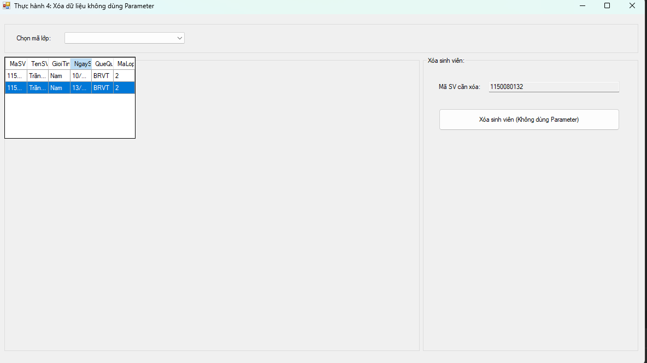

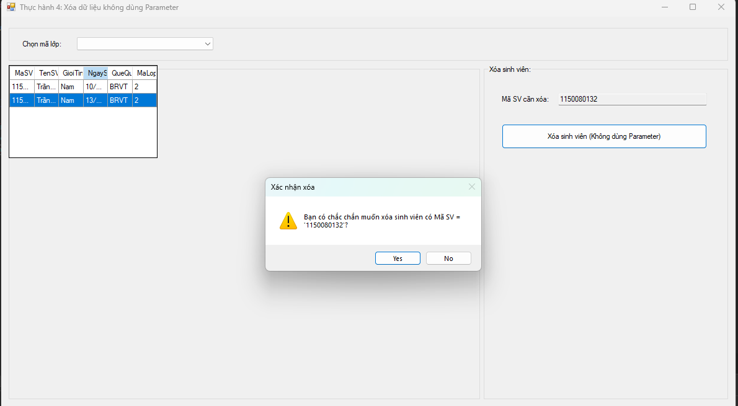

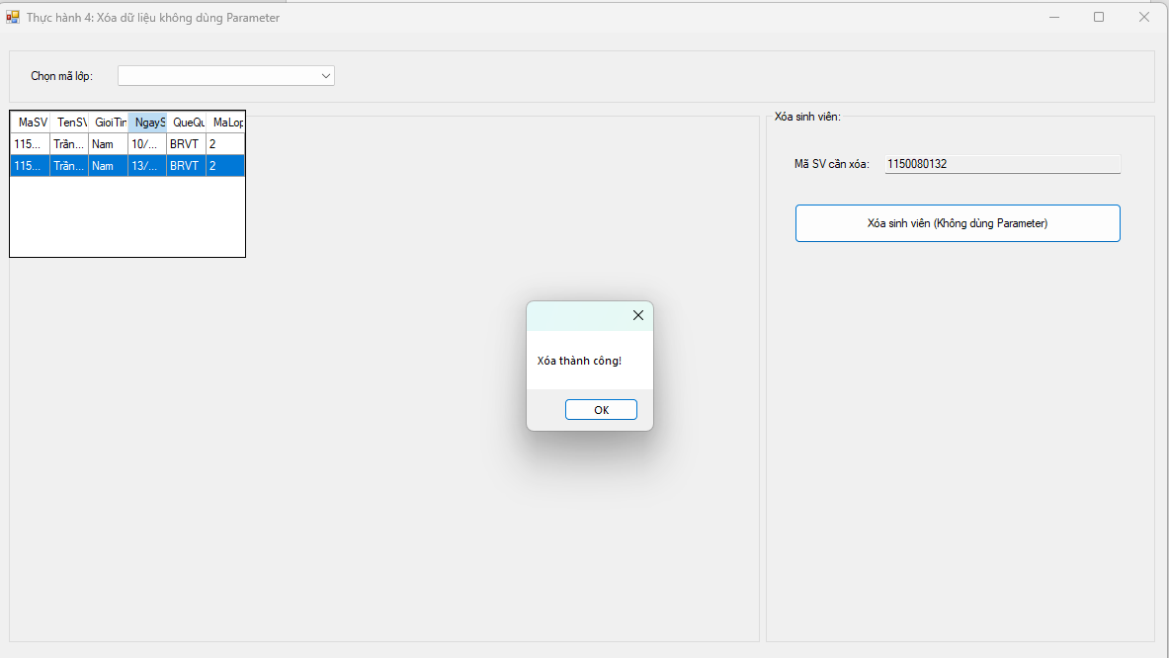

**Form4.cs**

using System;

using System.Configuration;

using System.Data;

using System.Data.SqlClient;

using System.Drawing;

using System.Windows.Forms;

namespace _1150080131_TranDuc_lab5

{

public partial class Form4 : Form

{

private readonly string _connStr =

ConfigurationManager.ConnectionStrings["QLSV"]?.ConnectionString

?? @"Data Source=LAPTOP-LQGGA8E3\MSSQLSERVER2;Initial Catalog=QLSV;Integrated Security=True;Persist Security Info=False;TrustServerCertificate=True";

public Form4()

{

InitializeComponent();

}

private SqlConnection Conn() => new SqlConnection(_connStr);

private void Form4_Load(object sender, EventArgs e)

{

// load lớp

using (var da = new SqlDataAdapter("SELECT MaLop FROM dbo.Lop ORDER BY MaLop;", Conn()))

{

var dt = new DataTable();

da.Fill(dt);

cboLop.DataSource = dt;

cboLop.DisplayMember = "MaLop";

cboLop.ValueMember = "MaLop";

cboLop.SelectedIndex = -1; // xem tất cả

}

LoadGrid(null);

}

private void LoadGrid(string maLop)

{

string sql = string.IsNullOrWhiteSpace(maLop)

? @"SELECT MaSV, TenSV, GioiTinh, NgaySinh, QueQuan, MaLop

FROM dbo.SinhVien ORDER BY MaSV;"

: $@"SELECT MaSV, TenSV, GioiTinh, NgaySinh, QueQuan, MaLop

FROM dbo.SinhVien WHERE MaLop = '{Esc(maLop)}' ORDER BY MaSV;";

using (var da = new SqlDataAdapter(sql, Conn()))

{

var dt = new DataTable();

da.Fill(dt);

dgvSV.DataSource = dt;

}

txtMaSV.Clear();

btnXoa.Enabled = false;

}

private static string Esc(string s) => (s ?? string.Empty).Replace("'", "''");

private void cboLop_SelectionChangeCommitted(object sender, EventArgs e)

{

LoadGrid(cboLop.SelectedValue?.ToString());

}

private void dgvSV_CellClick(object sender, DataGridViewCellEventArgs e)

{

if (e.RowIndex < 0) return;

var row = dgvSV.Rows[e.RowIndex];

txtMaSV.Text = row.Cells["MaSV"].Value?.ToString();

btnXoa.Enabled = !string.IsNullOrWhiteSpace(txtMaSV.Text);

}

private void btnXoa_Click(object sender, EventArgs e)

{

if (string.IsNullOrWhiteSpace(txtMaSV.Text))

{

MessageBox.Show("Hãy chọn một sinh viên để xóa.", "Thông báo");

return;

}

var maSV = txtMaSV.Text.Trim();

var confirm = MessageBox.Show(

$"Bạn có chắc chắn muốn xóa sinh viên có Mã SV = '{maSV}'?",

"Xác nhận xóa", MessageBoxButtons.YesNo, MessageBoxIcon.Warning);

if (confirm != DialogResult.Yes) return;

// KHÔNG dùng parameter theo yêu cầu bài: nối chuỗi

string sql = $"DELETE FROM dbo.SinhVien WHERE MaSV = '{Esc(maSV)}';";

try

{

using (var conn = Conn())

using (var cmd = new SqlCommand(sql, conn))

{

conn.Open();

int n = cmd.ExecuteNonQuery(); // ExecuteNonQuery để xóa

if (n == 1)

{

MessageBox.Show("Xóa thành công!");

LoadGrid(cboLop.SelectedIndex >= 0 ? cboLop.SelectedValue?.ToString() : null);

}

else

{

MessageBox.Show("Không có bản ghi nào bị xóa.");

}

}

}

catch (SqlException ex)

{

MessageBox.Show("SQL lỗi: " + ex.Message, "SQL Error",

MessageBoxButtons.OK, MessageBoxIcon.Error);

}

catch (Exception ex)

{

MessageBox.Show("Lỗi: " + ex.Message, "Error",

MessageBoxButtons.OK, MessageBoxIcon.Error);

}

}

}

}

**Form4.Desginer.cs**

namespace _1150080131_TranDuc_lab5

{

partial class Form4

{

private System.ComponentModel.IContainer components = null;

private System.Windows.Forms.GroupBox grpTop;

private System.Windows.Forms.Label lblChonLop;

private System.Windows.Forms.ComboBox cboLop;

private System.Windows.Forms.GroupBox grpLeft;

private System.Windows.Forms.DataGridView dgvSV;

private System.Windows.Forms.GroupBox grpRight;

private System.Windows.Forms.Label label1;

private System.Windows.Forms.TextBox txtMaSV;

private System.Windows.Forms.Button btnXoa;

protected override void Dispose(bool disposing)

{

if (disposing && (components != null)) components.Dispose();

base.Dispose(disposing);

}

private void InitializeComponent()

{

this.grpTop = new System.Windows.Forms.GroupBox();

this.lblChonLop = new System.Windows.Forms.Label();

this.cboLop = new System.Windows.Forms.ComboBox();

this.grpLeft = new System.Windows.Forms.GroupBox();

this.dgvSV = new System.Windows.Forms.DataGridView();

this.grpRight = new System.Windows.Forms.GroupBox();

this.btnXoa = new System.Windows.Forms.Button();

this.txtMaSV = new System.Windows.Forms.TextBox();

this.label1 = new System.Windows.Forms.Label();

this.grpTop.SuspendLayout();

this.grpLeft.SuspendLayout();

((System.ComponentModel.ISupportInitialize)(this.dgvSV)).BeginInit();

this.grpRight.SuspendLayout();

this.SuspendLayout();

//

// grpTop

//

this.grpTop.Anchor = ((System.Windows.Forms.AnchorStyles)(((System.Windows.Forms.AnchorStyles.Top | System.Windows.Forms.AnchorStyles.Left)

| System.Windows.Forms.AnchorStyles.Right)));

this.grpTop.Controls.Add(this.cboLop);

this.grpTop.Controls.Add(this.lblChonLop);

this.grpTop.Location = new System.Drawing.Point(12, 12);

this.grpTop.Name = "grpTop";

this.grpTop.Size = new System.Drawing.Size(1160, 60);

this.grpTop.TabIndex = 0;

this.grpTop.TabStop = false;

//

// lblChonLop

//

this.lblChonLop.AutoSize = true;

this.lblChonLop.Location = new System.Drawing.Point(20, 25);

this.lblChonLop.Text = "Chọn mã lớp:";

//

// cboLop

//

this.cboLop.DropDownStyle = System.Windows.Forms.ComboBoxStyle.DropDownList;

this.cboLop.Location = new System.Drawing.Point(110, 21);

this.cboLop.Size = new System.Drawing.Size(220, 24);

this.cboLop.SelectionChangeCommitted += new System.EventHandler(this.cboLop_SelectionChangeCommitted);

//

// grpLeft

//

this.grpLeft.Anchor = ((System.Windows.Forms.AnchorStyles)(((System.Windows.Forms.AnchorStyles.Top | System.Windows.Forms.AnchorStyles.Bottom)

| System.Windows.Forms.AnchorStyles.Left)));

this.grpLeft.Controls.Add(this.dgvSV);

this.grpLeft.Location = new System.Drawing.Point(12, 78);

this.grpLeft.Name = "grpLeft";

this.grpLeft.Size = new System.Drawing.Size(760, 540);

this.grpLeft.TabIndex = 1;

this.grpLeft.TabStop = false;

this.grpLeft.Text = "Danh sách sinh viên:";

//

// dgvSV

//

this.dgvSV.AllowUserToAddRows = false;

this.dgvSV.AllowUserToDeleteRows = false;

this.dgvSV.AutoSizeColumnsMode = System.Windows.Forms.DataGridViewAutoSizeColumnsMode.Fill;

this.dgvSV.BackgroundColor = System.Drawing.SystemColors.Window;

this.dgvSV.Dock = System.Windows.Forms.DockStyle.Fill;

this.dgvSV.ReadOnly = true;

this.dgvSV.RowHeadersVisible = false;

this.dgvSV.SelectionMode = System.Windows.Forms.DataGridViewSelectionMode.FullRowSelect;

this.dgvSV.CellClick += new System.Windows.Forms.DataGridViewCellEventHandler(this.dgvSV_CellClick);

//

// grpRight

//

this.grpRight.Anchor = ((System.Windows.Forms.AnchorStyles)(((System.Windows.Forms.AnchorStyles.Top | System.Windows.Forms.AnchorStyles.Bottom)

| System.Windows.Forms.AnchorStyles.Right)));

this.grpRight.Controls.Add(this.btnXoa);

this.grpRight.Controls.Add(this.txtMaSV);

this.grpRight.Controls.Add(this.label1);

this.grpRight.Location = new System.Drawing.Point(778, 78);

this.grpRight.Name = "grpRight";

this.grpRight.Size = new System.Drawing.Size(394, 540);

this.grpRight.TabIndex = 2;

this.grpRight.TabStop = false;

this.grpRight.Text = "Xóa sinh viên:";

//

// label1

//

this.label1.AutoSize = true;

this.label1.Location = new System.Drawing.Point(26, 48);

this.label1.Text = "Mã SV cần xóa:";

//

// txtMaSV

//

this.txtMaSV.Location = new System.Drawing.Point(120, 45);

this.txtMaSV.ReadOnly = true;

this.txtMaSV.Size = new System.Drawing.Size(240, 22);

//

// btnXoa

//

this.btnXoa.Enabled = false;

this.btnXoa.Location = new System.Drawing.Point(29, 95);

this.btnXoa.Size = new System.Drawing.Size(331, 40);

this.btnXoa.Text = "Xóa sinh viên (Không dùng Parameter)";

this.btnXoa.UseVisualStyleBackColor = true;

this.btnXoa.Click += new System.EventHandler(this.btnXoa_Click);

//

// Form4

//

this.AutoScaleDimensions = new System.Drawing.SizeF(8F, 16F);

this.ClientSize = new System.Drawing.Size(1184, 641);

this.Controls.Add(this.grpRight);

this.Controls.Add(this.grpLeft);

this.Controls.Add(this.grpTop);

this.Name = "Form4";

this.StartPosition = System.Windows.Forms.FormStartPosition.CenterScreen;

this.Text = "Thực hành 4: Xóa dữ liệu không dùng Parameter";

this.Load += new System.EventHandler(this.Form4_Load);

this.grpTop.ResumeLayout(false);

this.grpTop.PerformLayout();

this.grpLeft.ResumeLayout(false);

((System.ComponentModel.ISupportInitialize)(this.dgvSV)).EndInit();

this.grpRight.ResumeLayout(false);

this.grpRight.PerformLayout();

this.ResumeLayout(false);

}

}

}

**Áp dụng 3: Xóa dữ liệu có dùng Parameter.**

Cũng xóa dữ liệu của 1 sinh viên trong bảng SinhVien như ví dụ trên. Tuy nhiên,

trong chương trình có sử dụng các Parameter.

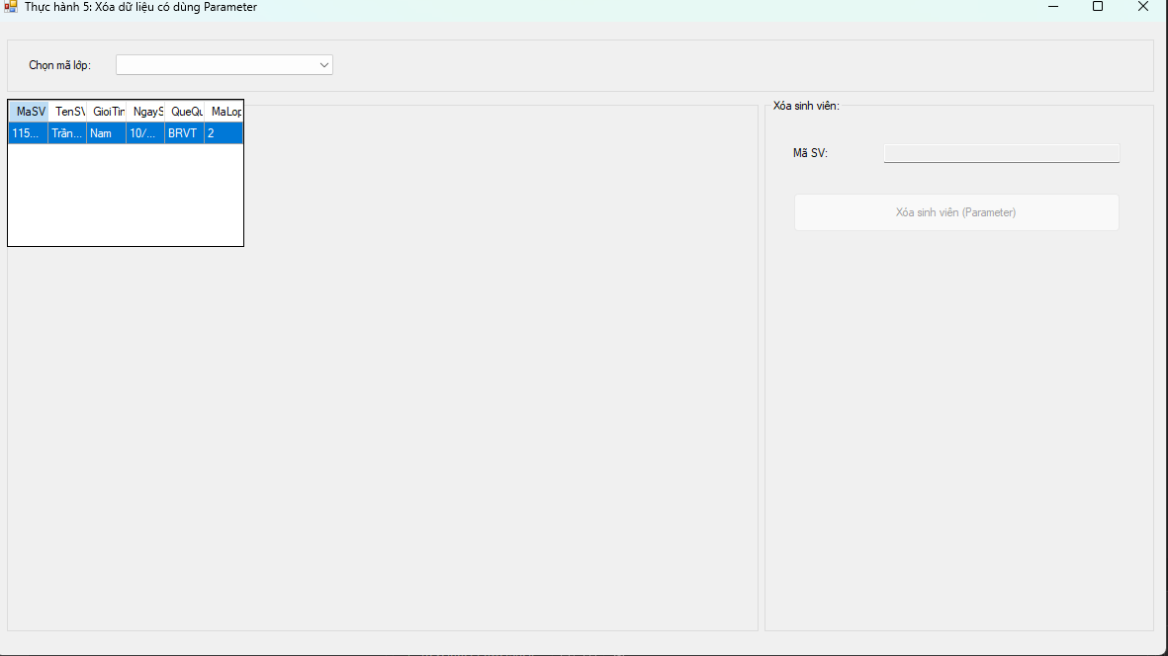

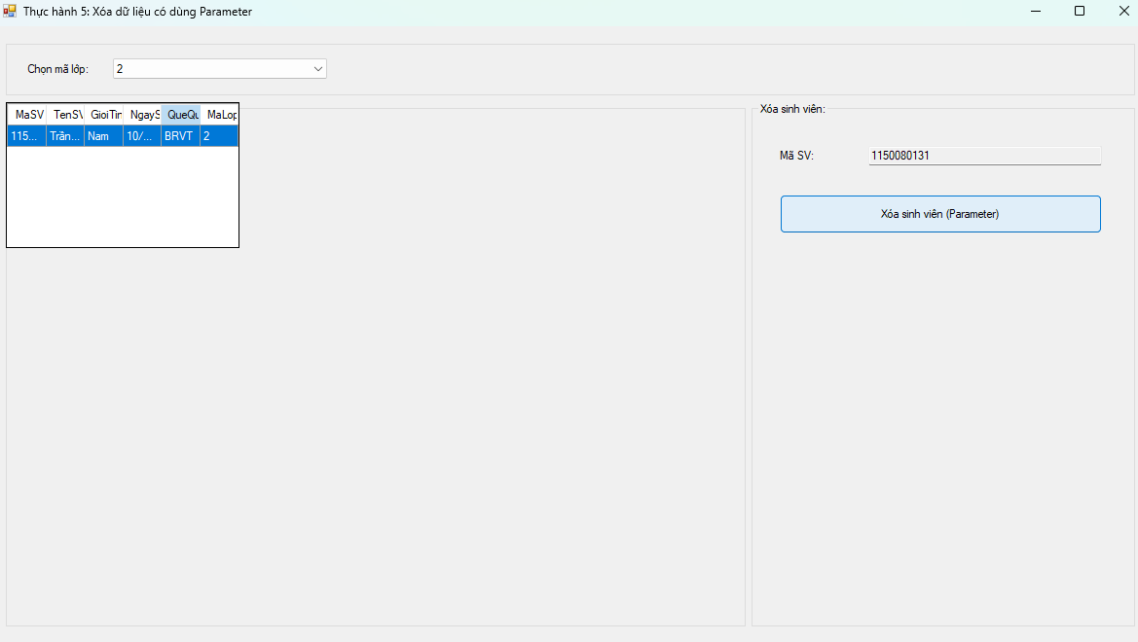

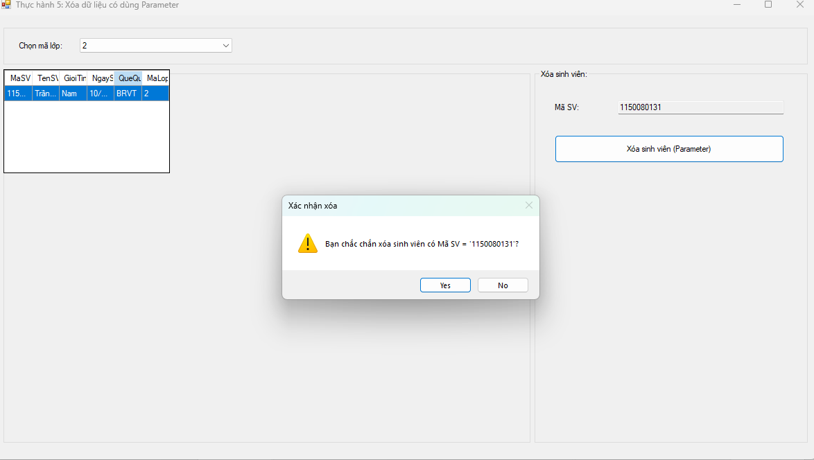

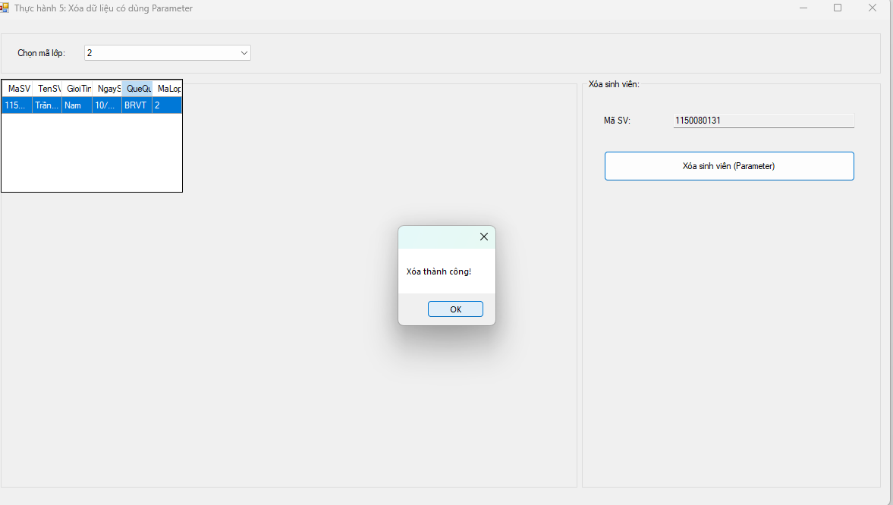

**Form5.cs**

using System;

using System.Configuration;

using System.Data;

using System.Data.SqlClient;

using System.Drawing;

using System.Windows.Forms;

namespace _1150080131_TranDuc_lab5

{

public partial class Form5 : Form

{

private readonly string _connStr =

ConfigurationManager.ConnectionStrings["QLSV"]?.ConnectionString

?? @"Data Source=LAPTOP-LQGGA8E3\MSSQLSERVER2;Initial Catalog=QLSV;Integrated Security=True;Persist Security Info=False;TrustServerCertificate=True";

public Form5()

{

InitializeComponent();

}

private SqlConnection Conn() => new SqlConnection(_connStr);

private void Form5_Load(object sender, EventArgs e)

{

LoadLop();

LoadGrid(null);

}

private void LoadLop()

{

const string sql = "SELECT MaLop FROM dbo.Lop ORDER BY MaLop;";

using (var da = new SqlDataAdapter(sql, Conn()))

{

var dt = new DataTable();

da.Fill(dt);

cboLop.DataSource = dt;

cboLop.DisplayMember = "MaLop";

cboLop.ValueMember = "MaLop";

cboLop.SelectedIndex = -1; // xem tất cả

}

}

private void LoadGrid(string maLop)

{

var sql = @"SELECT MaSV, TenSV, GioiTinh, NgaySinh, QueQuan, MaLop

FROM dbo.SinhVien {0} ORDER BY MaSV;";

var where = string.IsNullOrWhiteSpace(maLop) ? "" : "WHERE MaLop = @MaLop";

using (var conn = Conn())

using (var cmd = new SqlCommand(string.Format(sql, where), conn))

{

if (!string.IsNullOrWhiteSpace(maLop))

cmd.Parameters.Add(new SqlParameter("@MaLop", SqlDbType.VarChar, 20) { Value = maLop });

using (var da = new SqlDataAdapter(cmd))

{

var dt = new DataTable();

da.Fill(dt);

dgvSV.DataSource = dt;

}

}

txtMaSV.Clear();

btnXoa.Enabled = false;

}

private void cboLop_SelectionChangeCommitted(object sender, EventArgs e)

{

LoadGrid(cboLop.SelectedValue?.ToString());

}

private void dgvSV_CellClick(object sender, DataGridViewCellEventArgs e)

{

if (e.RowIndex < 0) return;

var row = dgvSV.Rows[e.RowIndex];

txtMaSV.Text = row.Cells["MaSV"].Value?.ToString();

btnXoa.Enabled = !string.IsNullOrWhiteSpace(txtMaSV.Text);

}

private void btnXoa_Click(object sender, EventArgs e)

{

if (string.IsNullOrWhiteSpace(txtMaSV.Text))

{

MessageBox.Show("Hãy chọn một sinh viên để xóa.");

return;

}

var maSV = txtMaSV.Text.Trim();

var confirm = MessageBox.Show(

$"Bạn chắc chắn xóa sinh viên có Mã SV = '{maSV}'?",

"Xác nhận xóa",

MessageBoxButtons.YesNo, MessageBoxIcon.Warning);

if (confirm != DialogResult.Yes) return;

const string SQL = "DELETE FROM dbo.SinhVien WHERE MaSV = @MaSV;";

try

{

using (var conn = Conn())

using (var cmd = new SqlCommand(SQL, conn))

{

cmd.Parameters.Add(new SqlParameter("@MaSV", SqlDbType.VarChar, 20) { Value = maSV });

conn.Open();

int n = cmd.ExecuteNonQuery(); // DELETE với Parameter

if (n == 1)

{

MessageBox.Show("Xóa thành công!");

LoadGrid(cboLop.SelectedIndex >= 0 ? cboLop.SelectedValue?.ToString() : null);

}

else

{

MessageBox.Show("Không có bản ghi nào bị xóa.");

}

}

}

catch (SqlException ex)

{

MessageBox.Show("SQL lỗi: " + ex.Message, "SQL Error",

MessageBoxButtons.OK, MessageBoxIcon.Error);

}

catch (Exception ex)

{

MessageBox.Show("Lỗi: " + ex.Message, "Error",

MessageBoxButtons.OK, MessageBoxIcon.Error);

}

}

}

}

**Form5.Desinger.cs**

namespace _1150080131_TranDuc_lab5

{

partial class Form5

{

private System.ComponentModel.IContainer components = null;

private System.Windows.Forms.GroupBox grpTop;

private System.Windows.Forms.Label lblChonLop;

private System.Windows.Forms.ComboBox cboLop;

private System.Windows.Forms.GroupBox grpLeft;

private System.Windows.Forms.DataGridView dgvSV;

private System.Windows.Forms.GroupBox grpRight;

private System.Windows.Forms.Label label1;

private System.Windows.Forms.TextBox txtMaSV;

private System.Windows.Forms.Button btnXoa;

protected override void Dispose(bool disposing)

{

if (disposing && (components != null)) components.Dispose();

base.Dispose(disposing);

}

private void InitializeComponent()

{

this.grpTop = new System.Windows.Forms.GroupBox();

this.cboLop = new System.Windows.Forms.ComboBox();

this.lblChonLop = new System.Windows.Forms.Label();

this.grpLeft = new System.Windows.Forms.GroupBox();

this.dgvSV = new System.Windows.Forms.DataGridView();

this.grpRight = new System.Windows.Forms.GroupBox();

this.btnXoa = new System.Windows.Forms.Button();

this.txtMaSV = new System.Windows.Forms.TextBox();

this.label1 = new System.Windows.Forms.Label();

this.grpTop.SuspendLayout();

this.grpLeft.SuspendLayout();

((System.ComponentModel.ISupportInitialize)(this.dgvSV)).BeginInit();

this.grpRight.SuspendLayout();

this.SuspendLayout();

//

// grpTop

//

this.grpTop.Anchor = ((System.Windows.Forms.AnchorStyles)(((System.Windows.Forms.AnchorStyles.Top | System.Windows.Forms.AnchorStyles.Left)

| System.Windows.Forms.AnchorStyles.Right)));

this.grpTop.Controls.Add(this.cboLop);

this.grpTop.Controls.Add(this.lblChonLop);

this.grpTop.Location = new System.Drawing.Point(12, 12);

this.grpTop.Name = "grpTop";

this.grpTop.Size = new System.Drawing.Size(1160, 60);

this.grpTop.TabIndex = 0;

this.grpTop.TabStop = false;

//

// cboLop

//

this.cboLop.DropDownStyle = System.Windows.Forms.ComboBoxStyle.DropDownList;

this.cboLop.Location = new System.Drawing.Point(110, 21);

this.cboLop.Size = new System.Drawing.Size(220, 24);

this.cboLop.SelectionChangeCommitted += new System.EventHandler(this.cboLop_SelectionChangeCommitted);

//

// lblChonLop

//

this.lblChonLop.AutoSize = true;

this.lblChonLop.Location = new System.Drawing.Point(20, 25);

this.lblChonLop.Text = "Chọn mã lớp:";

//

// grpLeft

//

this.grpLeft.Anchor = ((System.Windows.Forms.AnchorStyles)(((System.Windows.Forms.AnchorStyles.Top | System.Windows.Forms.AnchorStyles.Bottom)

| System.Windows.Forms.AnchorStyles.Left)));

this.grpLeft.Controls.Add(this.dgvSV);

this.grpLeft.Location = new System.Drawing.Point(12, 78);

this.grpLeft.Name = "grpLeft";

this.grpLeft.Size = new System.Drawing.Size(760, 540);

this.grpLeft.TabIndex = 1;

this.grpLeft.TabStop = false;

this.grpLeft.Text = "Danh sách sinh viên:";

//

// dgvSV

//

this.dgvSV.AllowUserToAddRows = false;

this.dgvSV.AllowUserToDeleteRows = false;

this.dgvSV.AutoSizeColumnsMode = System.Windows.Forms.DataGridViewAutoSizeColumnsMode.Fill;

this.dgvSV.BackgroundColor = System.Drawing.SystemColors.Window;

this.dgvSV.Dock = System.Windows.Forms.DockStyle.Fill;

this.dgvSV.ReadOnly = true;

this.dgvSV.RowHeadersVisible = false;

this.dgvSV.SelectionMode = System.Windows.Forms.DataGridViewSelectionMode.FullRowSelect;

this.dgvSV.CellClick += new System.Windows.Forms.DataGridViewCellEventHandler(this.dgvSV_CellClick);

//

// grpRight

//

this.grpRight.Anchor = ((System.Windows.Forms.AnchorStyles)(((System.Windows.Forms.AnchorStyles.Top | System.Windows.Forms.AnchorStyles.Bottom)

| System.Windows.Forms.AnchorStyles.Right)));

this.grpRight.Controls.Add(this.btnXoa);

this.grpRight.Controls.Add(this.txtMaSV);

this.grpRight.Controls.Add(this.label1);

this.grpRight.Location = new System.Drawing.Point(778, 78);

this.grpRight.Name = "grpRight";

this.grpRight.Size = new System.Drawing.Size(394, 540);

this.grpRight.TabIndex = 2;

this.grpRight.TabStop = false;

this.grpRight.Text = "Xóa sinh viên:";

//

// label1

//

this.label1.AutoSize = true;

this.label1.Location = new System.Drawing.Point(26, 48);

this.label1.Text = "Mã SV:";

//

// txtMaSV

//

this.txtMaSV.Location = new System.Drawing.Point(120, 45);

this.txtMaSV.ReadOnly = true;

this.txtMaSV.Size = new System.Drawing.Size(240, 22);

//

// btnXoa

//

this.btnXoa.Enabled = false;

this.btnXoa.Location = new System.Drawing.Point(29, 95);

this.btnXoa.Size = new System.Drawing.Size(331, 40);

this.btnXoa.Text = "Xóa sinh viên (Parameter)";

this.btnXoa.UseVisualStyleBackColor = true;

this.btnXoa.Click += new System.EventHandler(this.btnXoa_Click);

//

// Form5

//

this.AutoScaleDimensions = new System.Drawing.SizeF(8F, 16F);

this.ClientSize = new System.Drawing.Size(1184, 641);

this.Controls.Add(this.grpRight);

this.Controls.Add(this.grpLeft);

this.Controls.Add(this.grpTop);

this.Name = "Form5";

this.StartPosition = System.Windows.Forms.FormStartPosition.CenterScreen;

this.Text = "Thực hành 5: Xóa dữ liệu có dùng Parameter";

this.Load += new System.EventHandler(this.Form5_Load);

this.grpTop.ResumeLayout(false);

this.grpTop.PerformLayout();

this.grpLeft.ResumeLayout(false);

((System.ComponentModel.ISupportInitialize)(this.dgvSV)).EndInit();

this.grpRight.ResumeLayout(false);

this.grpRight.PerformLayout();

this.ResumeLayout(false);

}

}

}